CST-250 Activity 1: Designing Multilayer Object-Oriented Applications with Separation of Concerns

Introduction 2

Overview 4

Part 1 – Test-Driven Development (TDD) Introduction to Unit Testing with xUnit 5

Part 2 – Vehicle Class Library 19

Part 3 –Console Application 49

Console App Challenges 65

Part 4 – GUI Vehicle Store 66

GUI App Challenges 109

What You Learned in This Activity 110

Check for Understanding 111

Deliverables 115

# Introduction

This lesson, "Designing Multilayer Object-Oriented Applications with Separation of Concerns," emphasizes structuring software with clear division between user interface, business logic, and data access as well as two of the four pillars of object-oriented programming (OOP).

1. **Separation of Concerns** is a software design principal that splits a project into distinct sections to address different pieces of a program. Common sections include a presentation/user interface, business logic, and data access.
   1. **Presentation/User Interface (UI)** is what the user interacts with. The UI should be responsible only for displaying information to the user and collecting user inputs. It should not contain business logic or directly manage data storage/access.
   2. **Business Logic** consists of business rules or capabilities that handle the information exchange between the UI and data access. For example, a business logic class could handle calculations or make sure that rules for logic are enforced (i.e., a customer only receives a discount if…).
   3. **Data Access** is where your data resides (i.e., using lists to keep track of data) if an external database is not present. If a database is present, the data access layer oversees getting data to and from the database.
2. **Multilayer Application Design**, also referred to as N-layer architecture, is a common implementation of the separation of concerns. The sections above become layers of the application. N-layer architecture is a helpful design practice as it makes it easier to update logic or data access without having to update every part of an application. N-layer architecture also allows a programmer to detach and attach a new presentation layer without having to redo all the logic and data of the application itself. It also helps avoid repeated code. A common layer structure is a presentation layer, a business logic layer, and a data access layer.
3. **Object-Oriented Programming** (OOP) works with the separation of concerns to help organize code to be reusable, scalable, and manageable. The four pillars of OOP are encapsulation, abstraction, inheritance, and polymorphism. This activity focuses on abstraction, inheritance, and polymorphism.
   1. **Encapsulation** refers to the creation of classes to protect certain data. This protects the state of objects and enforces object control. Encapsulation frequently uses private and internal classes, properties, methods, and variables.
   2. **Abstraction** works by hiding the implementation details of classes and methods to simplify the interface and reduce complexity for a programmer using the class. The programmer can use the methods within a class without ever knowing, or needing to know, how it works.
   3. **Inheritance** refers to creating new classes from existing ones to reuse, extend, or modify the original properties and/or methods of the class. This promotes code reuse and a hierarchical relationship structure.
   4. **Polymorphism** allows different objects to respond differently to the same method call. This means that a singular class or interface higher on the hierarchy can be used for different underlying data types.
4. In this activity, students will be introduced to the principles of **test-driven development (TDD)** and the practice of writing **unit tests** using the **xUnit framework** in C#. Through hands-on exercises with the CarClassLibrary application, students will learn how to create automated tests that validate both object models and business logic. They will apply the **Red → Green → Refactor** cycle of TDD, writing tests first to drive code design and implementation. By the end of this activity, students will understand how unit testing improves code reliability, supports maintainable architecture, and increases developer confidence when making changes or enhancements to an application.
5. **The GCU College of Engineering and Technology's Coding Guidelines and Best Practices for C#**, available in Class Resources, must be followed in all CST-250 projects to ensure consistency, readability, and professionalism in student code. These guidelines promote a clear separation of concerns by organizing code into the models, BusinessLogicLayer, and DataAccessLayer folders. The document also outlines essential standards for casing, naming conventions, code structure, commenting, and organization. Additionally, it emphasizes best practices in object-oriented design, exception handling, and the use of design patterns. Adhering to these expectations is required for successful completion of course assignments.

# Overview

**Objective**: Create two versions of an application that utilize the same back-end classes and data sources to showcase the separation of concerns, N-layer architecture, and object-oriented programing principles.

**Details**: We will build three separate projects:

1. Class Library – contains the objects and lists for the inventory and shopping cart. This will be used in both the console and GUI applications.
   1. Vehicle Model class – contains the general vehicle properties (id, make, model, year, price, and number of wheels).
   2. Car Model class – extends the vehicle model class with additional properties specific to a car (convertible status and trunk size).
   3. Pickup Model class – extends the vehicle model class with additional properties specific to a pickup (if the pickup has a bed cover and the bed size).
   4. Motorcycle Model class – extends the vehicle model class with additional properties specific to a motorcycle (if the motorcycle has a side car and the seat height).
   5. Store Logic class – contains business layer logic for the program.
   6. Store data access object (DAO) class – contains methods to add and manipulate vehicle data.
2. Console App – uses a loop to create an interactive application including:
   1. Creating new vehicles for the inventory.
   2. Placing vehicles into the shopping cart.
   3. Checking out to get the final price of the cart.
3. Windows Forms App – a graphical user interface to perform the same functionality as the console app.

# Part 1 – Test-Driven Development (TDD) Introduction to Unit Testing with xUnit

**Objective:**

* You will design and implement the Car class and StoreLogic class **by first writing tests** — using the **Red → Green → Refactor** cycle.
* Do NOT write the classes first—you write tests first, which forces you to think about what your classes should do!

| **Step** | **Description** |
| --- | --- |
| **Red** | Write a failing test for a behavior that does not exist yet. |
| **Green** | Implement just enough code to make the test pass. |
| **Refactor** | Clean up the code (and tests), keeping all tests passing. |

1. Start a new project in Visual Studio and choose the Class Library option as shown in .

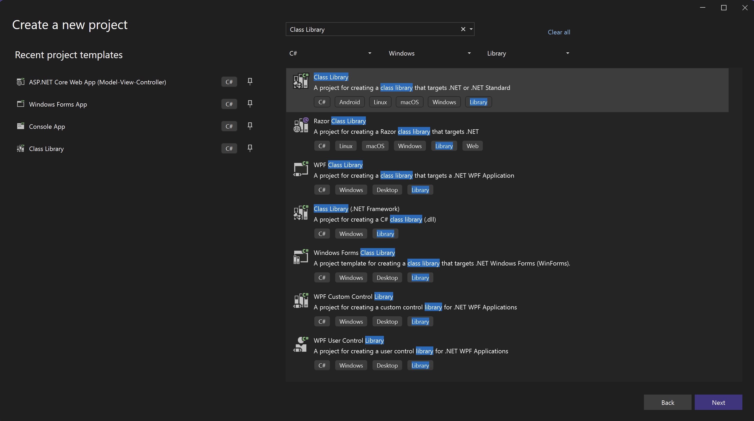

Figure : Creating a new class library.

1. Name the project VehicleClassLibrary as shown in Figure 2 and choose the most recent long-term support .NET framework.

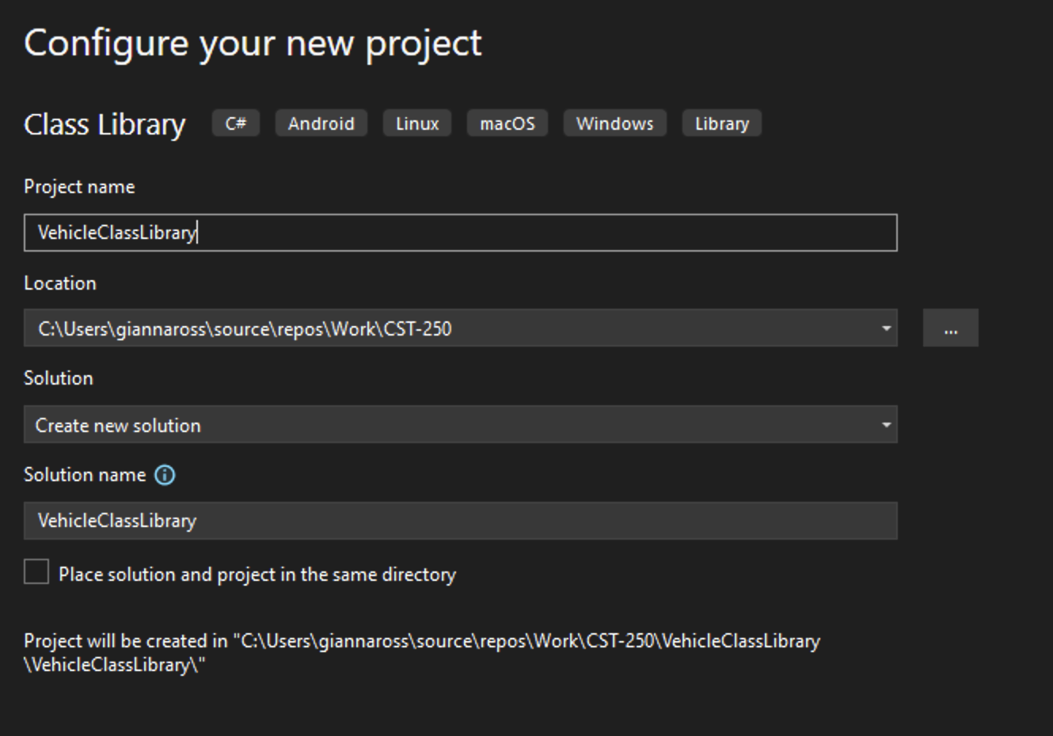

Figure : Create a VehicleClassLibrary project.



* Add the project to source control.Add the project to source control..
* See the class resources for a detailed tutorial on GitHub source control.on GitHub source control.

VehicleClassLibrary will be empty for now. The first step is to create the xUnit Test Project.

Make sure all NuGet packages are installed as shown in Figure 3.

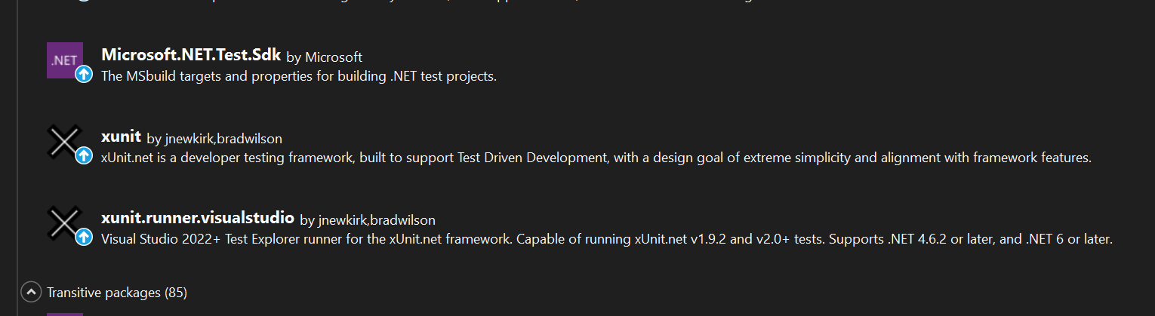

Figure : NuGet packages for xUnit testing

1. Create VehicleClassLibrary.Tests (xUnit Test Project). Add a new project as shown in Figure 4 by right-clicking on the Solution.

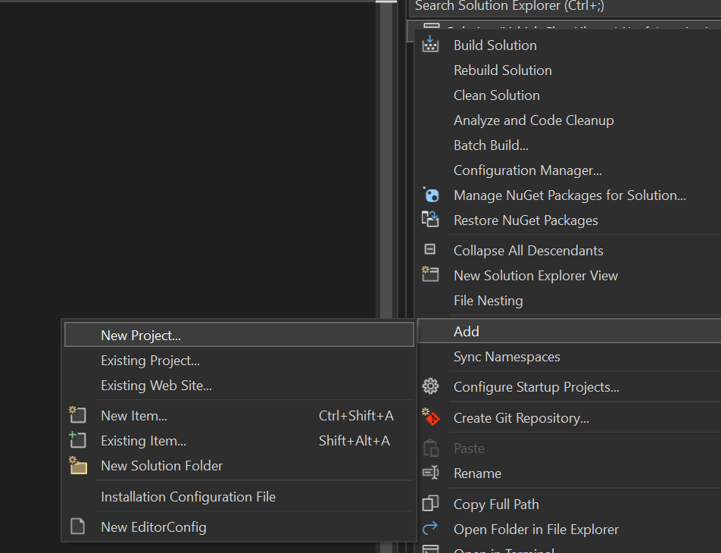

Figure : Add a New Project.

1. Select xUnit Test Project as shown in . Make sure and select the C# version.

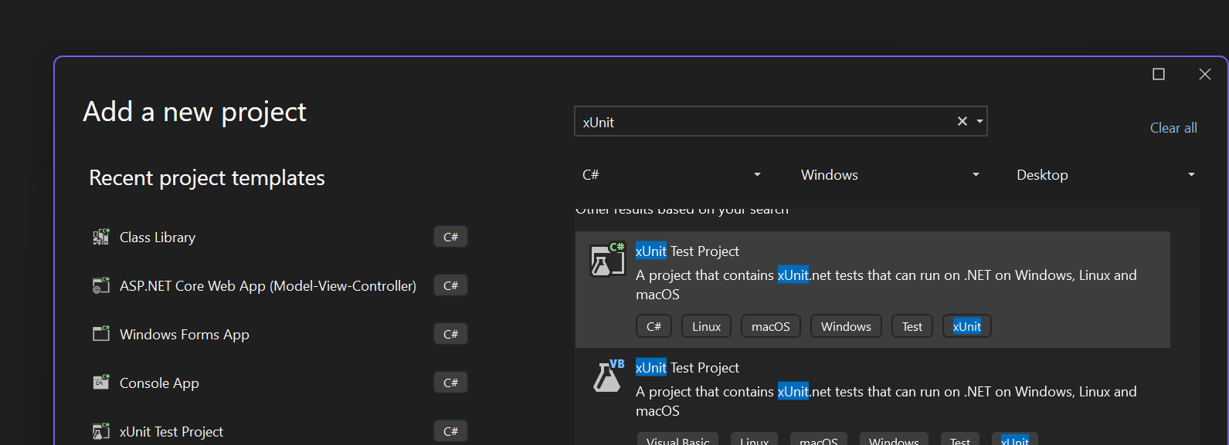

Figure : Add a new project by selecting xUnit Test Project for C#.

1. Name the project VehicleClassLibrary.Tests as shown in .

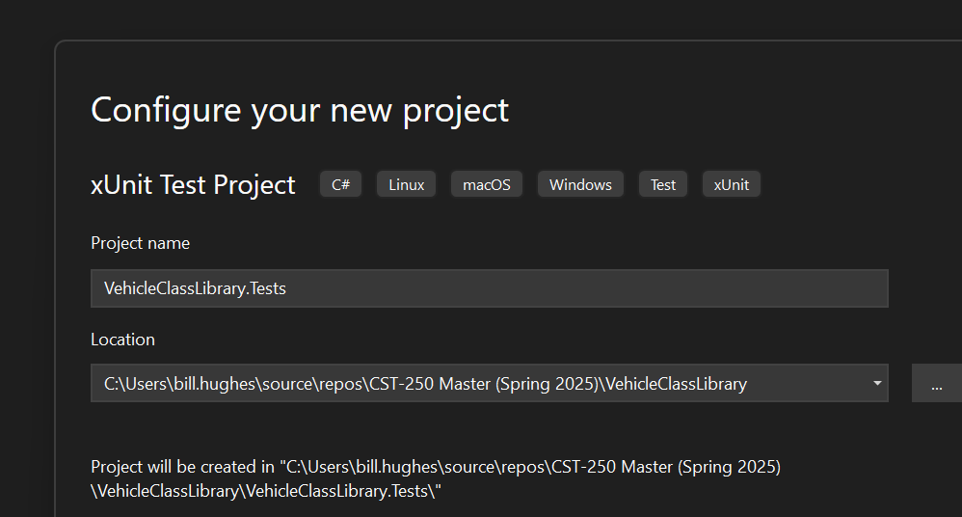

Figure : Name the xUnit project.

1. The Solution Explorer should look like .

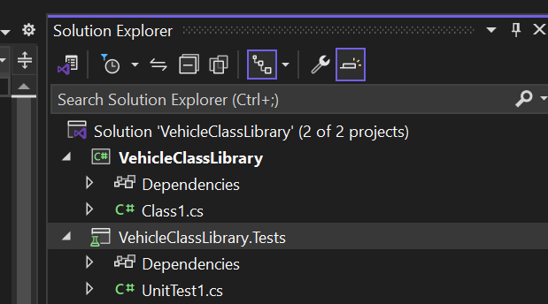

Figure : Solution Explorer after adding project for xUnit Tests

1. Add a Project Reference to VehicleClassLibrary as shown in Figures 8, 9, and 10.

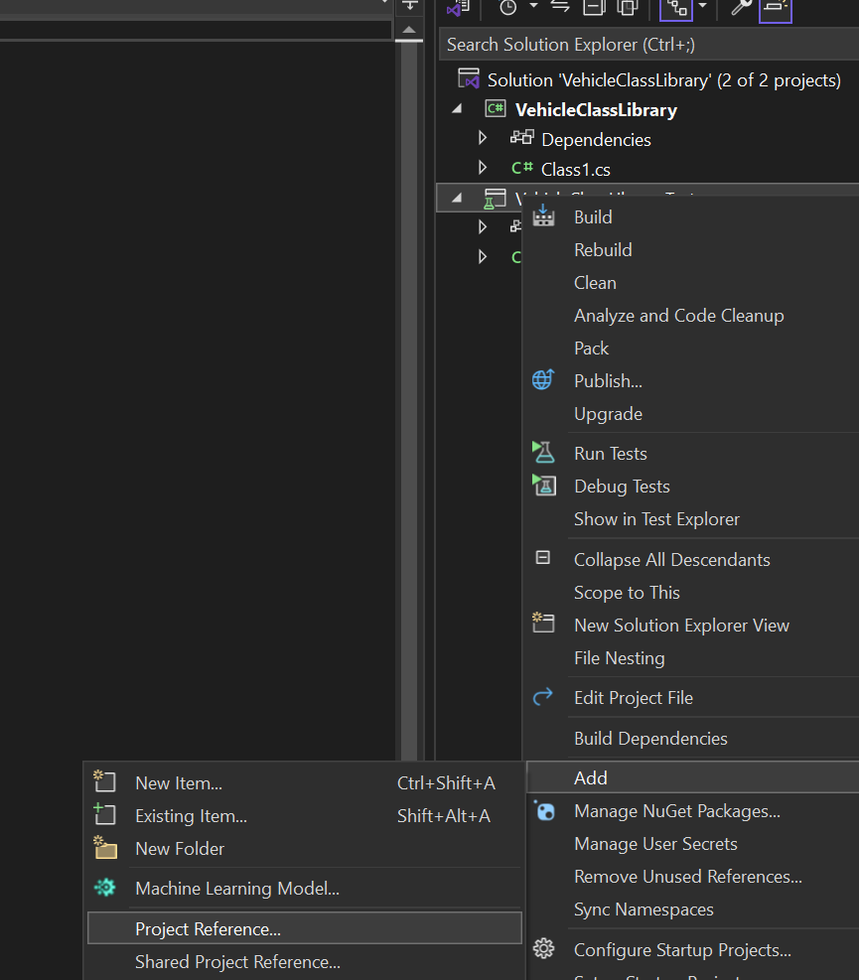

Figure : Add a Project Reference by Right-clicking on VehicleClassLibrary.Tests.

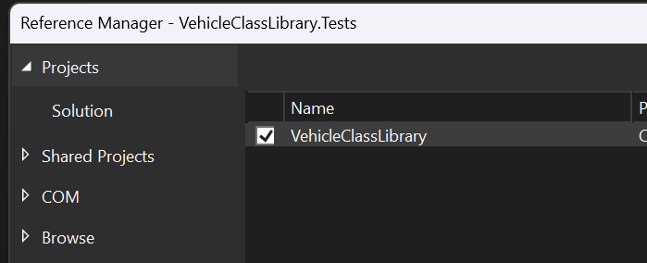

Figure : Check the box to add VehicleClassLibrary as a reference.

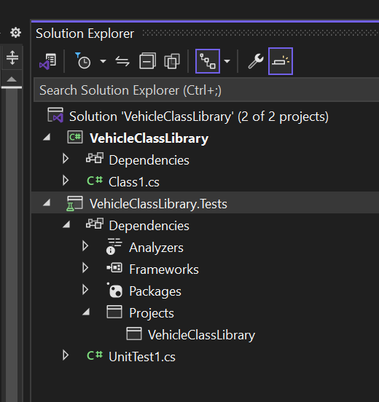

Figure : Expand the Dependencies and verify Projects has the added reference.

1. Rename UnitTest1.cs in VehicleClassLibrary.Tests to "StoreLogicTests.cs" as shown in . Proper naming convention for a test class is plural since this class will hold multiple test methods. Also, it is proper naming convention to add the word Test after the actual class name being tested; therefore, this xUnit StoreLogicTest.cs will test StoreLogic.cs.

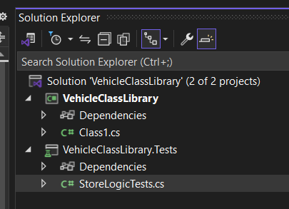

Figure : UnitTest1.cs is now StoreLogicTests.cs.

1. **At this stage, it is essential to create unified modeling language (UML) diagrams before moving forward.** The UML diagrams serve as a blueprint for your application, ensuring that all class properties and methods are clearly defined, structured, and fully understood. Completing this step first is critical, as it directly informs the design and implementation of accurate and effective xUnit tests. Skipping or rushing this stage can lead to design flaws or incomplete test coverage later in development.
2. **General Tips for xUnit test methods:**
   1. Use PascalCase for test method names
   2. Underscores between parts of the name are common and helpful, called "descriptive name with underscores."
   3. The test name should clearly describe **what is being tested** and **what is expected.**
   4. **Use pattern MethodName_StateUnderTest_ExpectedBehavior or MethodName_ExpectedResult_OptionalCondition.**
   5. **Test only one behavior per test method.**
   6. **How do determine which methods to unit test:**
      1. **Methods that are pure business logic.**
      2. **Methods that manipulate state (changes the data inside the object).**
      3. **Methods that return data.**
3. Write the unit test code for the AddVehicleToInventory method.

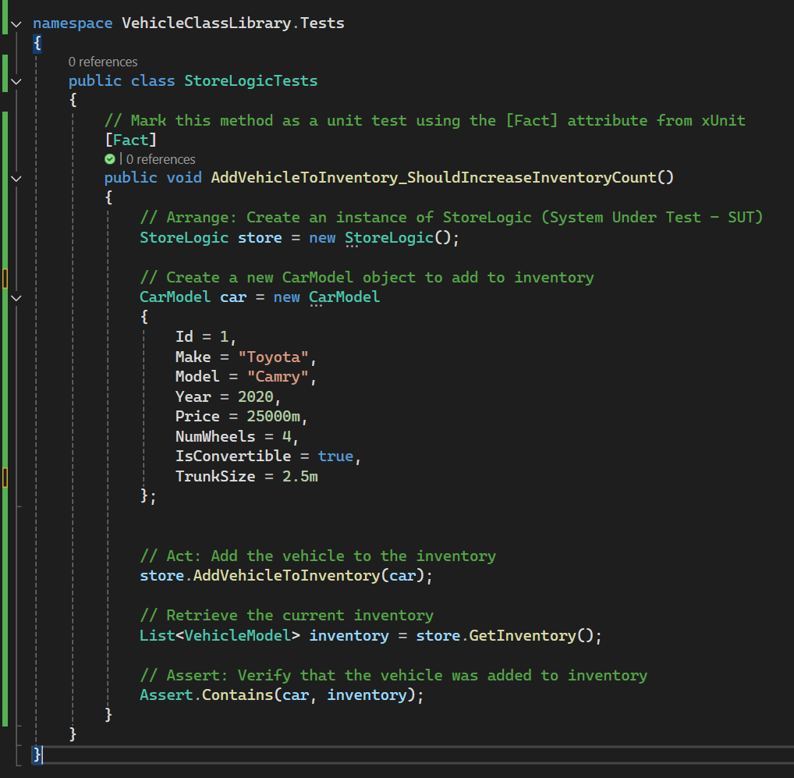

Figure : xUnit Test for AddVehicleToInventory

1. Write the unit test code for the GetInventory method.

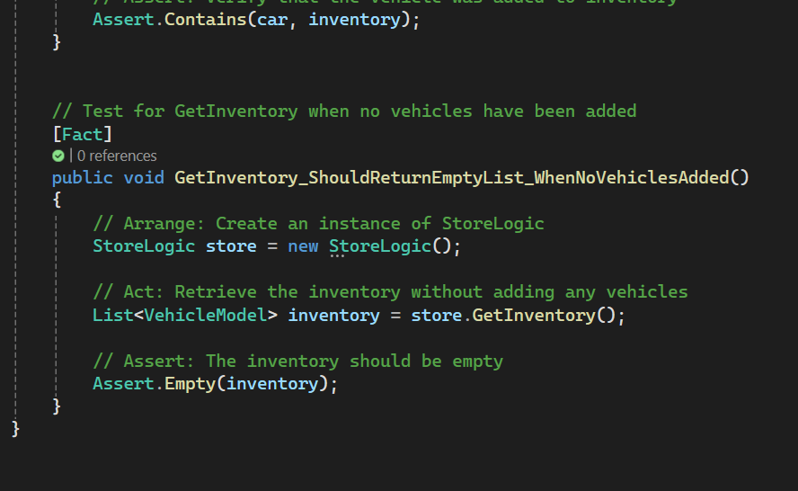

Figure : xUnit Test for GetInventory method

1. Write the unit test code for the AddVehicleToCart method.

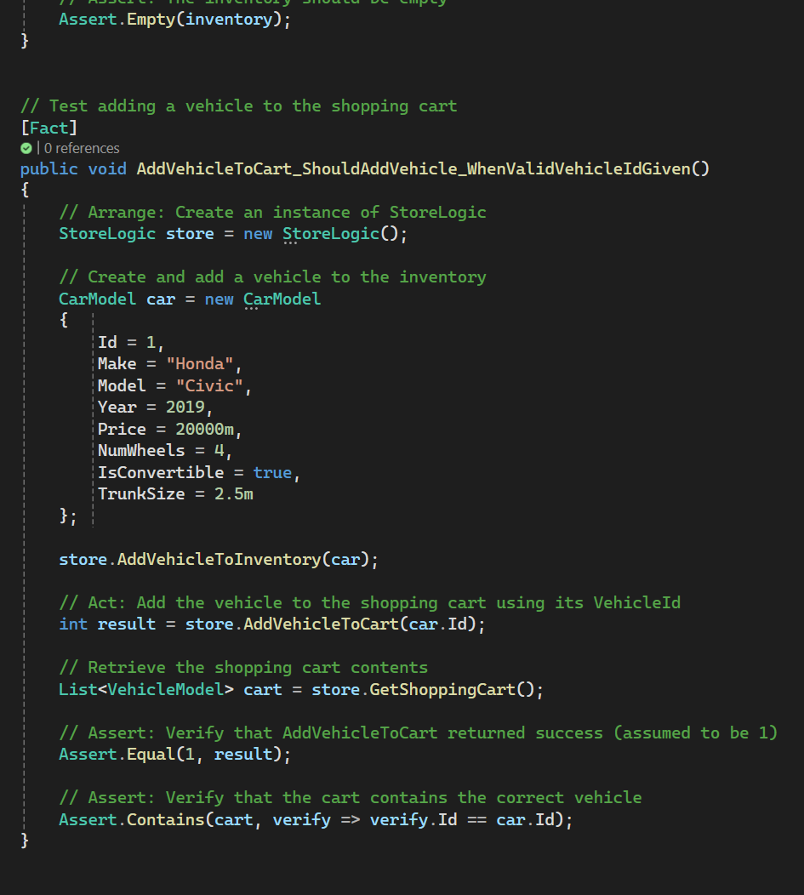

Figure : xUnit Test for AddVehicleToCart methodAd

1. Write the unit test code for the GetShoppingCart method.

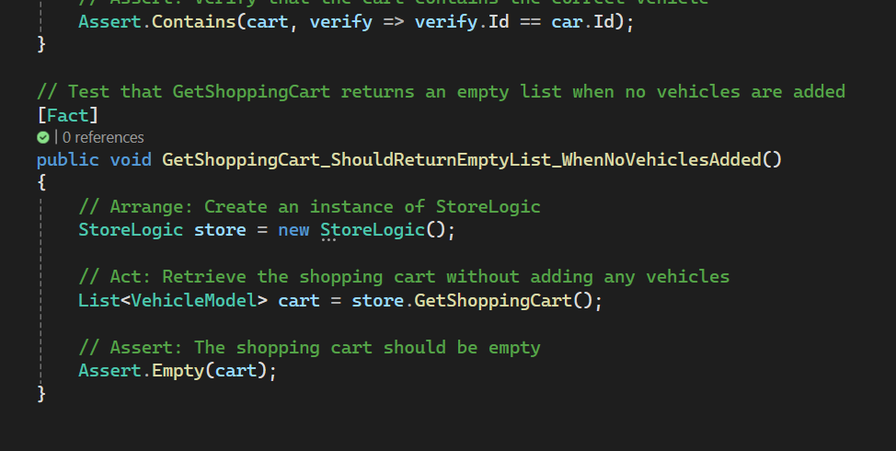

Figure : xUnit test for GetShoppingCart method

1. Create the xUnit tests for Checkout method.

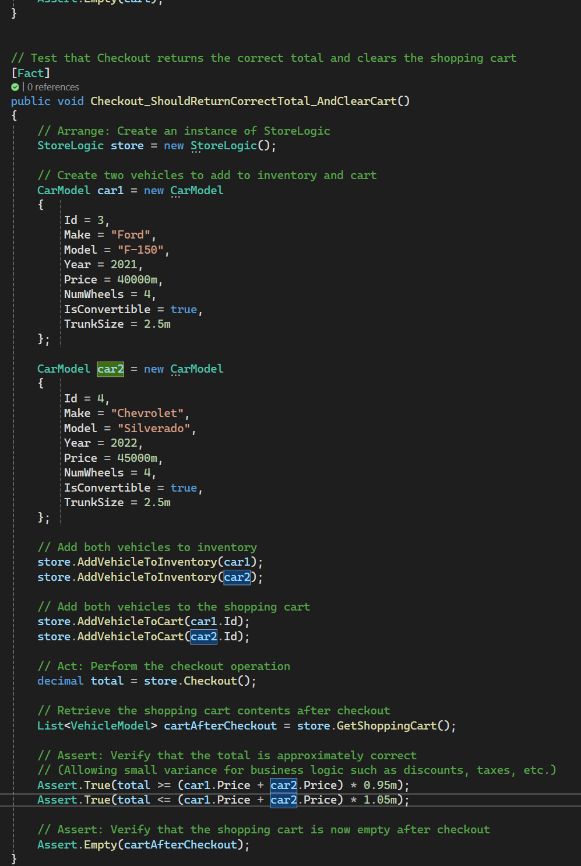

Figure : xUnit Test for Checkout method



* Add the project to source control.
* See the class resources for a detailed tutorial on GitHub source control.

1. How to run the xUnit tests after the methods have been designed:
   1. Select View > Test Explorer as shown in .

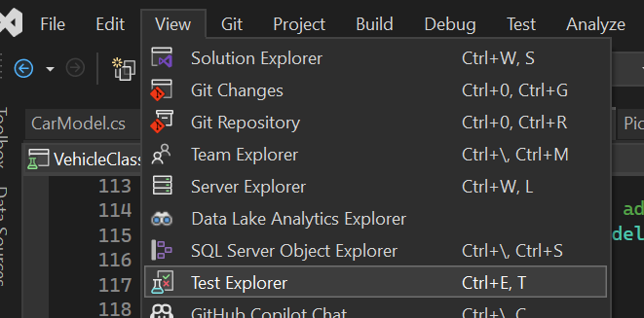

Figure 17: Open up the Test Explorer Window

* 1. 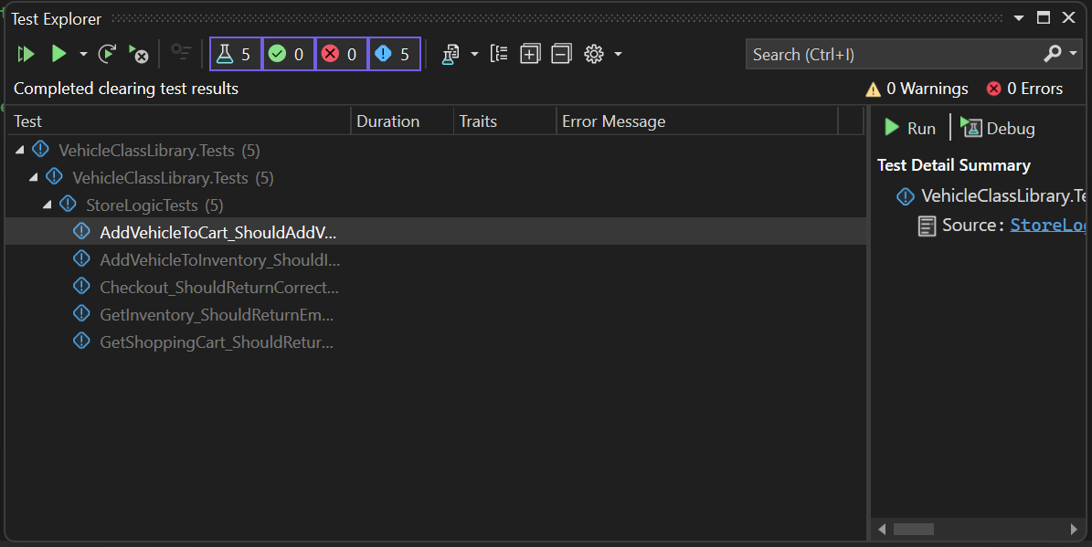A window will become visible that has the title "Test Explorer" and shows all the xUnit Tests as shown in Figure 18.

Figure 18: Test Explorer Window

* 1. 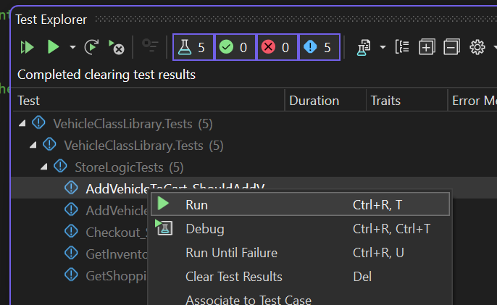To run a single test, highlight the test to run and right-click on the test. Then select Run from the menu as shown in Figure 19.

Figure 19: Run a single test.

* 1. To run all the tests, select the green run button in the menu as shown in Figure 20.

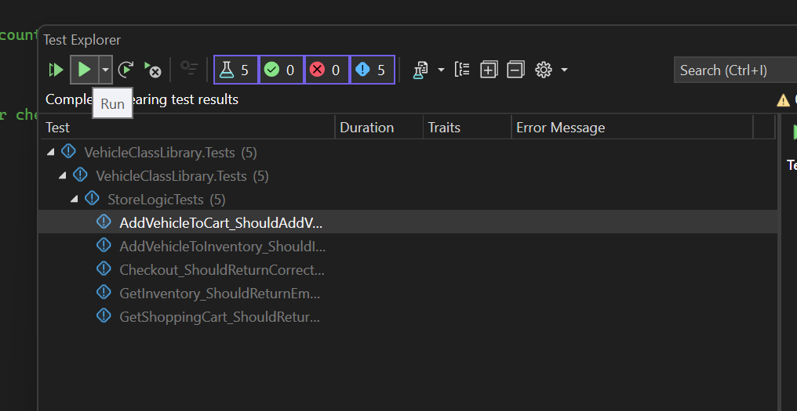

Figure 20: Run all xUnit Tests.

# Part 2 – Vehicle Class Library

**Objectives:**

* Create classes in C# that will be usable as a back end for the two versions of the application.
* Understand how abstraction is applied by exposing only the essential features of a class while hiding the unnecessary internal details.
* Understand how inheritance is applied by enabling a class to acquire the properties and behaviors of another class, promoting code reuse and logical hierarchy.
* Understand how polymorphism is applied by allowing objects of different types to be treated through a common interface, enabling flexible and interchangeable code.

1. In the VehicleClassLibrary we created in Part 1, delete the Class1.cs file in the Solution Explorer as shown in Figure 21.

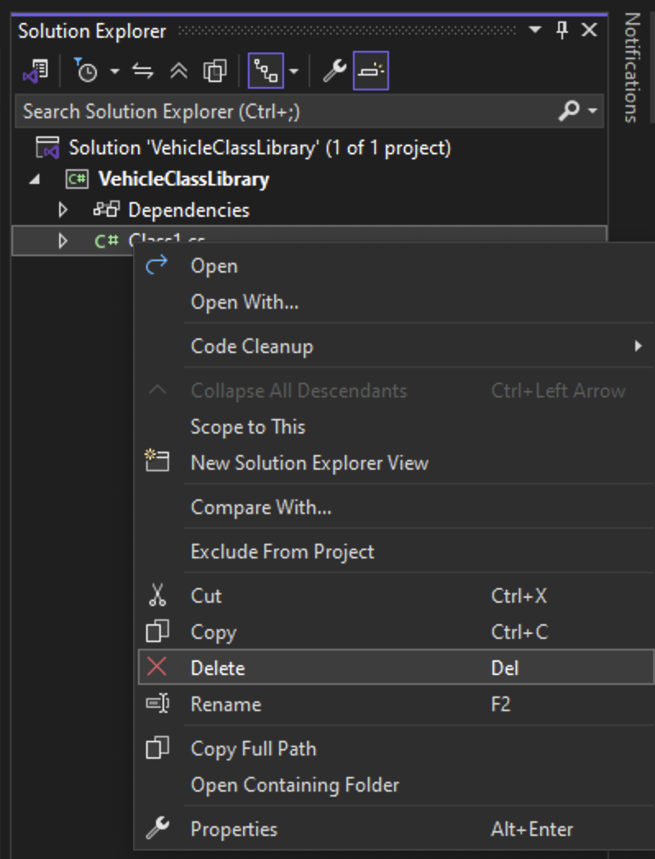

Figure : Delete the Class1.cs file.

1. Create two new folders in the project named Models and Services as shown in Figure 22. Inside the Services folder, add two folders named BusinessLogicLayer and DataAccessLayer. Figure 23 shows the solution explorer with the correct folder structure. This step adds abstraction by organizing the project in logical layers. By placing data definitions in the **Models** folder, business rules in the **BusinessLogicLayer**, and data handling code in the **DataAccessLayer**, you separate ***what*** each part of the application does from ***how*** it does it.

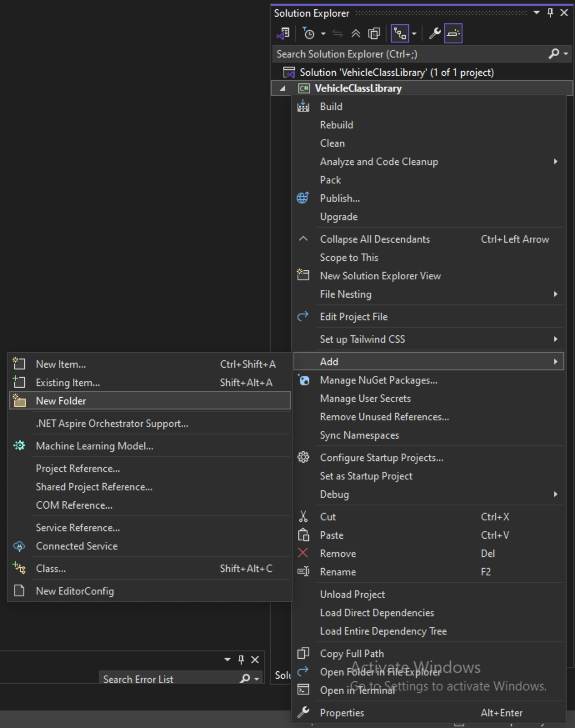

Figure : Adding a new folder to the project.

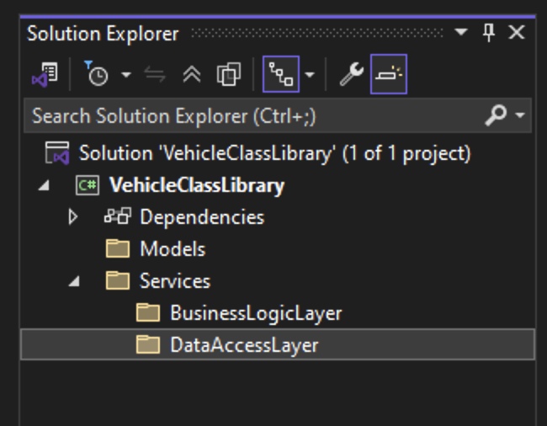

Figure : The Solution Explorer after the folders have been added.

1. Add a new class to the Models folder named VehicleModel.cs as shown in Figures 24 and 25. This class will act as a base class and be inherited by the car, pickup, and motorcycle classes to show the uses of polymorphism and inheritance.

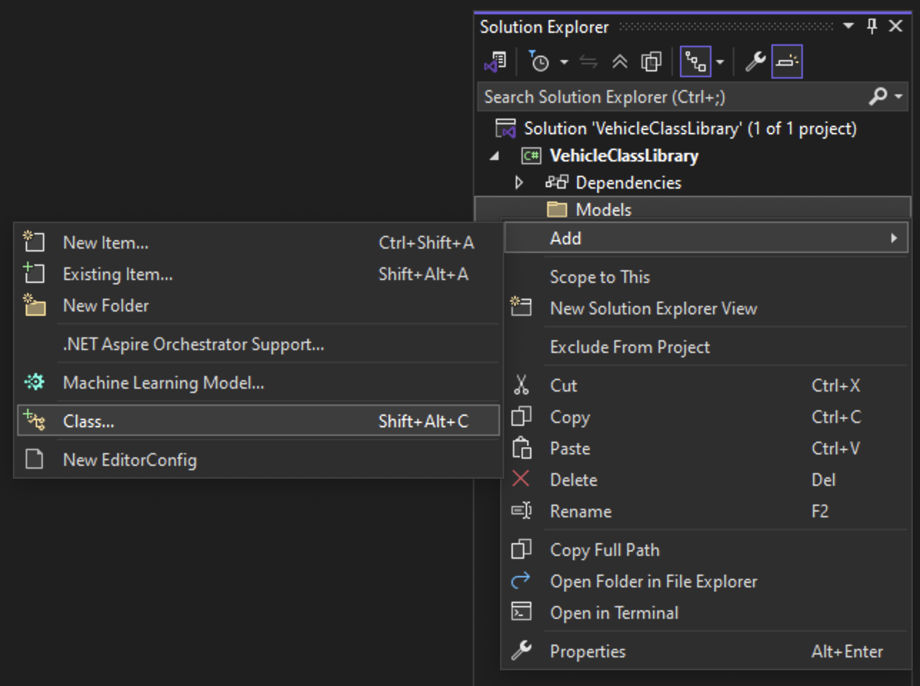

Figure : Adding a new class to the Models folder.

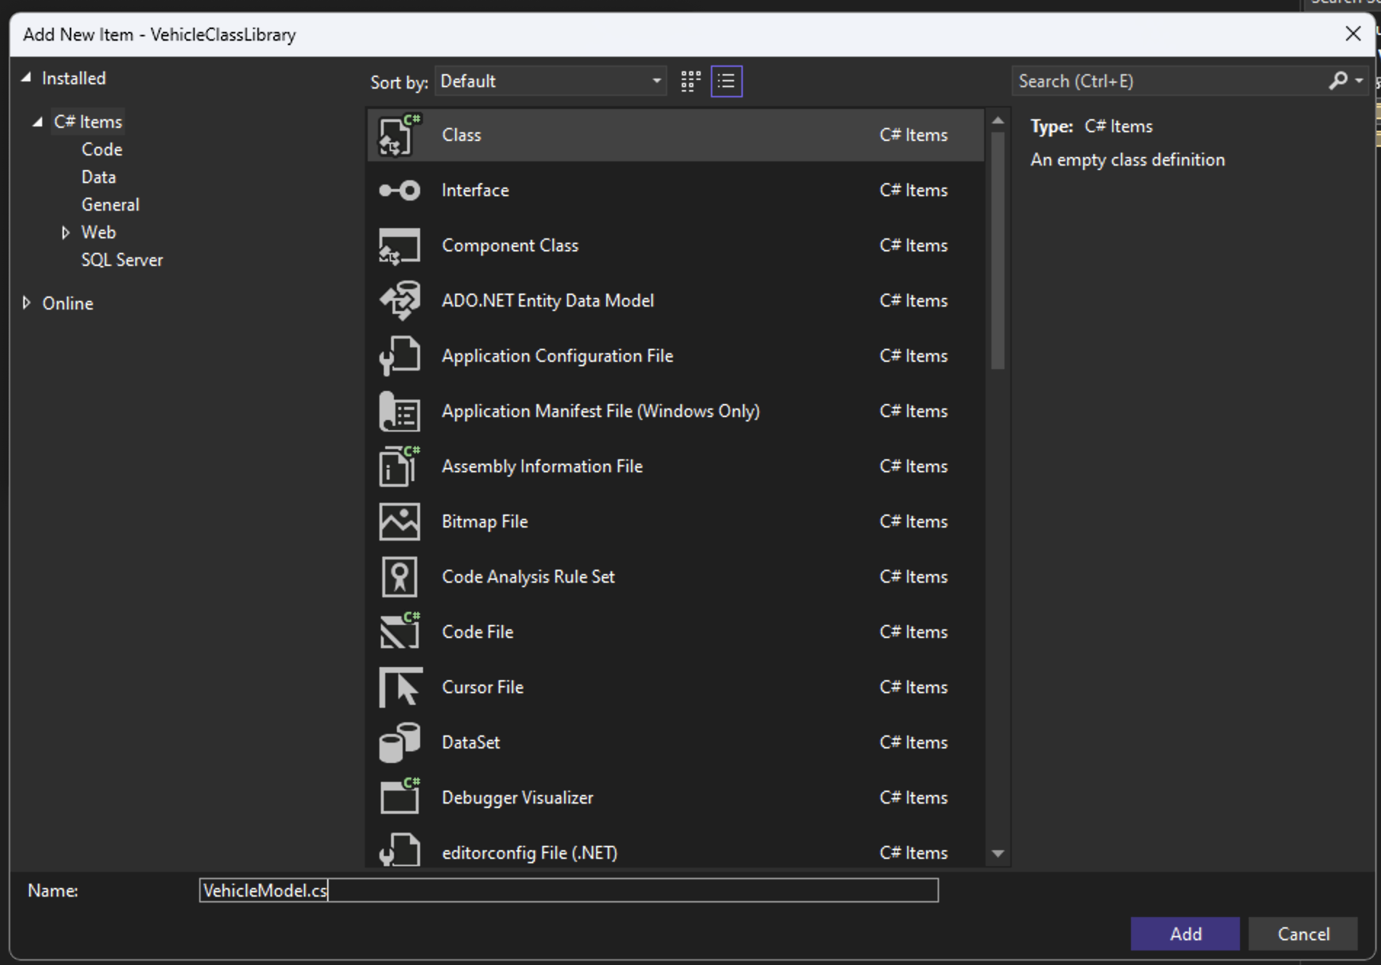

Figure : Adding the VehicleModel class to the project.

1. Add a citation to the top of the class as shown in . The citation should include your name, the class, the date, the project, and any resources used (i.e., code acquired from external websites or a textbook).

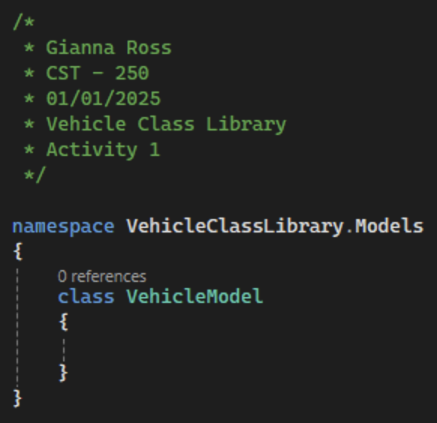

Figure : VehicleModel class with a citation.

1. Change the VehicleModel class to a public class, so that classes outside of the project will be able to access the class. Additionally, add six properties to the VehicleModel class: an int Id, a string Make, a string Model, an int Year, a decimal Price, and an int NumWheels, shown in . Class level variables should use PascalCase and can be created using the prop shortcut in Visual Studio.

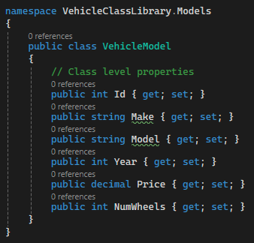

Figure : VehicleModel class with Id, Make, Model, Year, Price, and NumWheels properties

1. Constructor methods are called when a new instance of a class is created. The name of a constructor must match the name of its class. The VehicleModel class will have two constructors. One will have no parameters, known as a default constructor, and the other will accept six parameters, known as a parameterized constructor. In Visual Studio, "Quick Actions and Refactoring" in the right-click menu has an option to Generate constructors, which can make the creation of constructors easier. The default constructor can be used to set default values for properties. The default value for Price should specify the number as a decimal by appending the letter m to the number. The parametrized constructor should accept parameters for the Id, Make, Model, Year, Price, and NumWheels of the VehicleModel, as shown in .

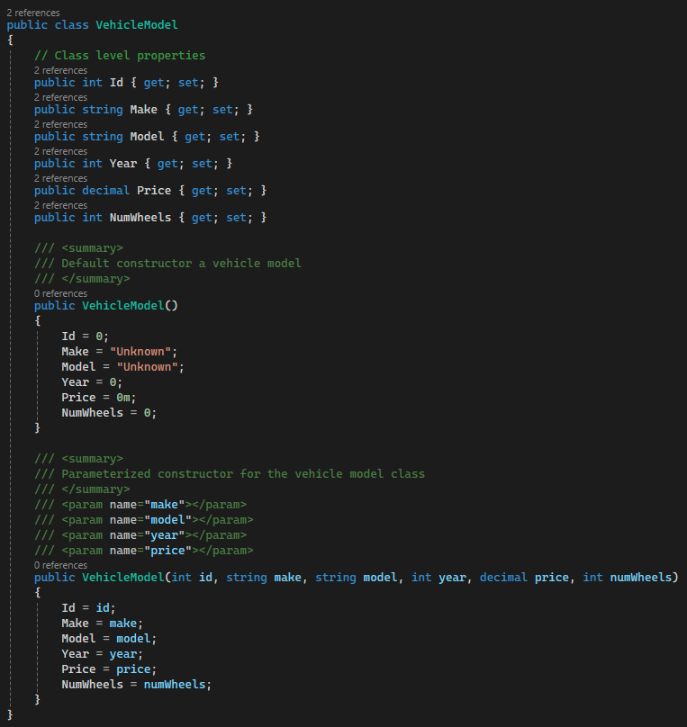

Figure : A default constructor and a parameterized constructor for the VehicleModel class.

1. Lastly, we need to override the ToString method for the VehicleModel class as shown in Figure 29. This will allow us to format how general VehicleModels are printed later in this activity instead of using the default method, which will show the location in memory of the VehicleModel. We can use the string interpolation method to format how we see each VehicleModel's data. This allows us to directly reference variables within the string by surrounding the variable name in curly braces. Additionally, we can use the currency formatter for the price of each VehicleModel. The C in Price:C2 specifies that the value will be currency and will show the appropriate symbol and the 2 signifies how many decimal places the currency should have.

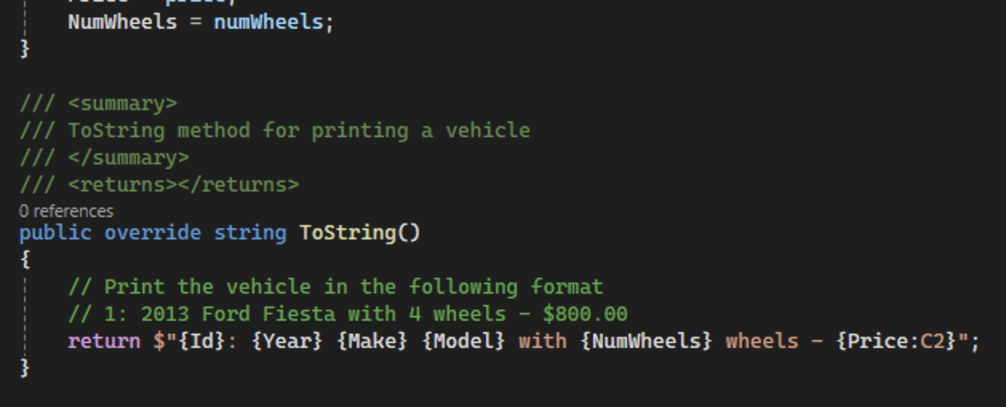

Figure : ToString method override for the VehicleModel class.

1. Next, add another public class named CarModel to the Models folder and add a citation as shown in Figure 30.

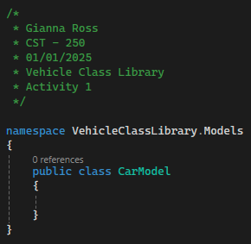

Figure : CarModel class with a citation.

1. Extend the VehicleModel class by adding " : VehicleModel" after the CarModel declaration as shown in Figure 31. This will allow us to reuse the VehicleModels properties and methods while adding car-specific properties and methods.

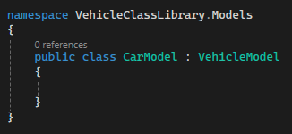

Figure : Extending the VehicleModel

1. Next, add two properties to the CarModel: a bool IsConvertible and a decimal TrunkSize as shown in Figure 32. These properties are specific to cars and should not be included in the general vehicle model.

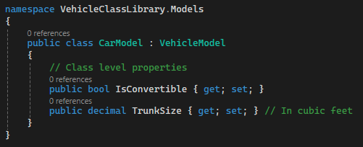

Figure : Adding car-specific properties to the car model.

1. Next, we will create the default and parameterized constructors for the CarModel as shown in Figure 33. To call both the CarModel constructor and the VehicleModel constructor, we can add " : base(attributes)" to the constructor definition. The attributes in the base call will mirror the VehicleModel constructor parameters.

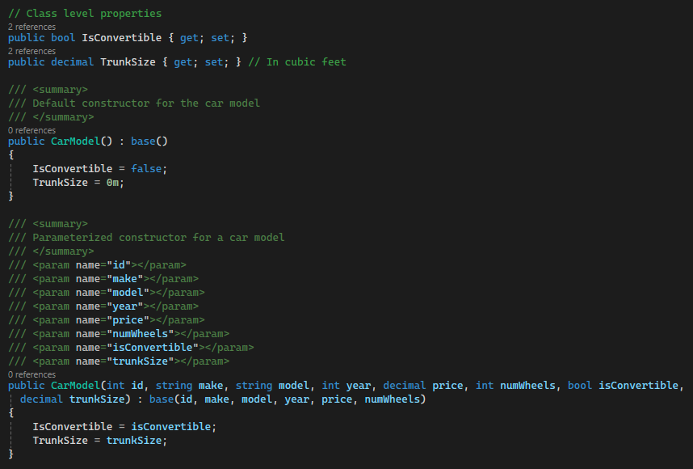

Figure : CarModel constructors with calls to the base constructors

1. Add a ToString method to the CarModel so that all the CarModel's information is displayed as shown in Figure 34. We can use a ternary operator to get a string to show if the CarModel is a convertible. This works similarly to an in-line if statement with a condition followed by the true and false results.

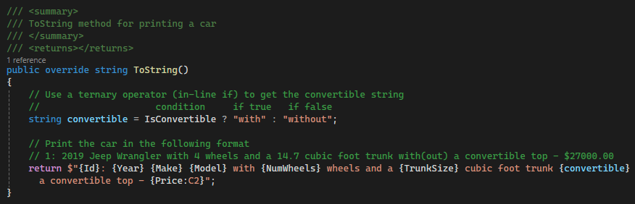

Figure : Overriding the CarModel ToString

1. Add a second public model named MotorcycleModel that extends the VehicleModel as shown in Figure 35. Remember to add the citation to the top of the class.

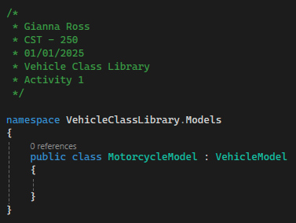

Figure : MotorcycleModel class that extends the vehicle model

1. Next add two, motorcycle-specific properties to the MotorcycleModel: a bool HasSideCar and a decimal SeatHeight as shown in Figure 36.

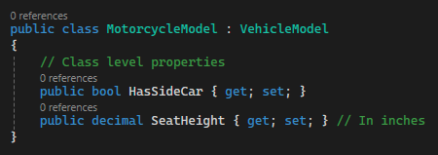

Figure : Adding properties to the MotorcycleModel

1. Create default and parameterized constructors for the MotorcycleModel, with their respective base constructor calls as shown in Figure 37.

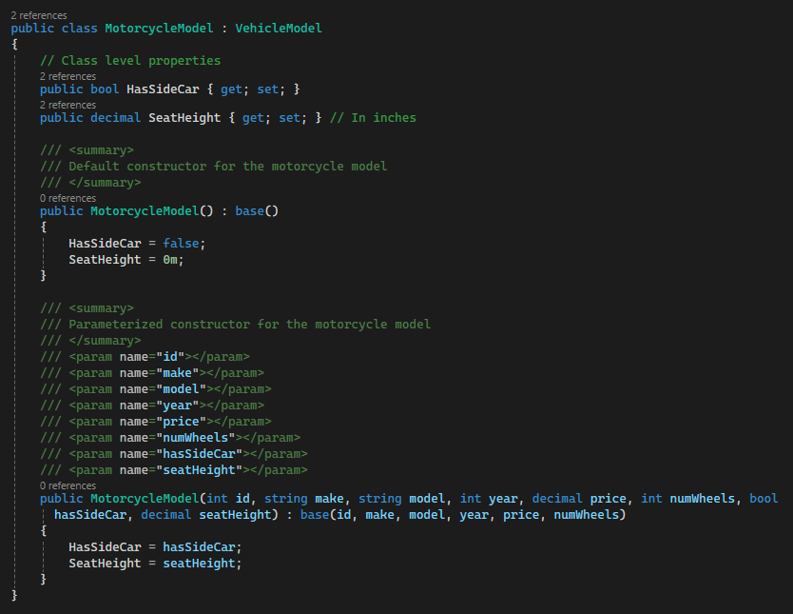

Figure : Constructors for the motorcycle model class

1. Add a ToString method to the MotorcycleModel so that the end user can see the seat height and the side car status as shown in Figure 38.

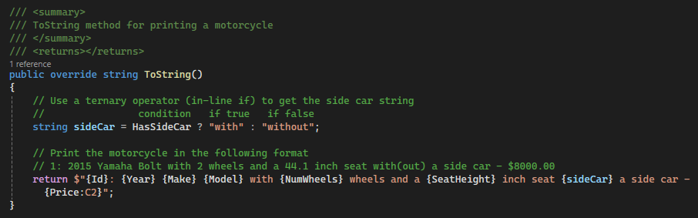

Figure : MotorcycleModel ToString method

1. Our fourth model will be a PickupModel. Create a public class named PickupModel that extends the VehicleModel with a citation. Add two properties to the pickup that will be unique to that type of vehicle: a bool HasBedCover and a decimal BedSize, as shown in Figure 39.

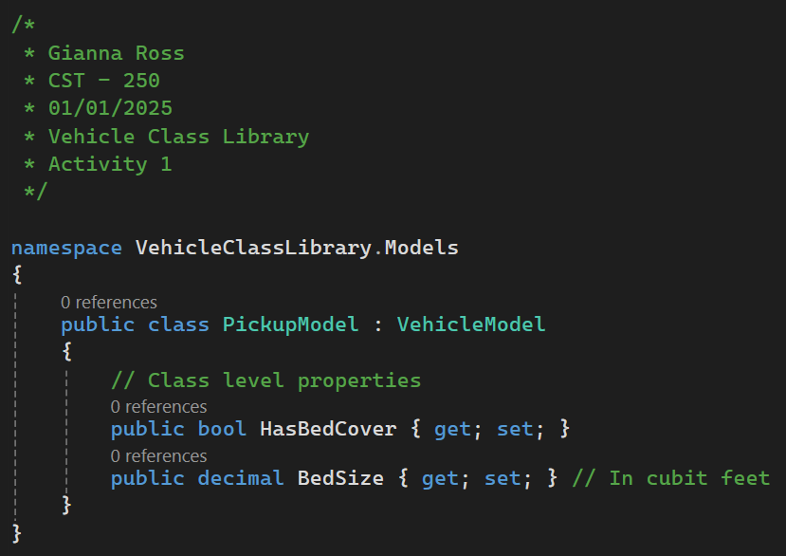

Figure : PickupModel class with two properties and a citation

1. Create default and parameterized constructors for the PickupModel, with their respective base constructor calls as shown in Figure 40.

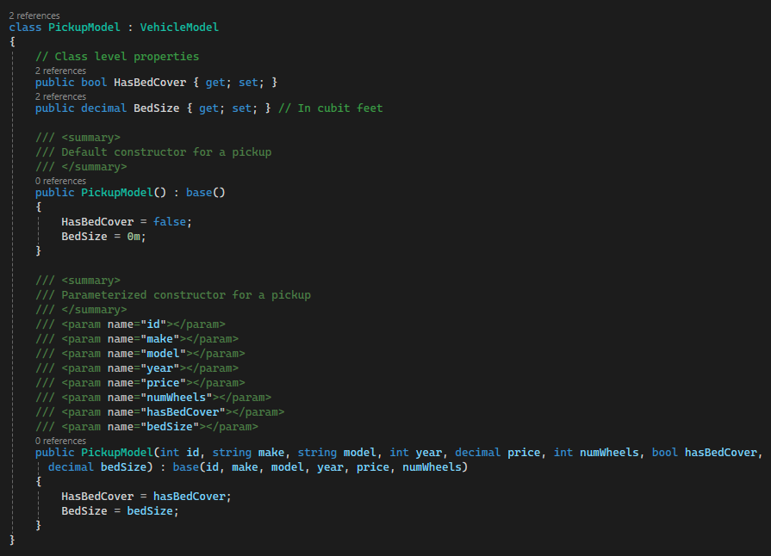

Figure : PickupModel constructors

1. Finally, override the ToString method for the PickupModel as shown in Figure 41.

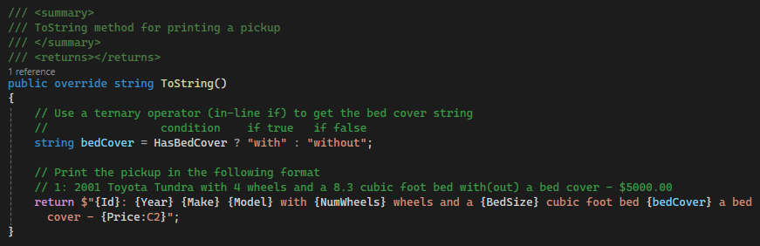

Figure : PickupModel ToString method

1. Right-click on the DataAccessLayer folder and add a new class named StoreDAO (data access object). Make the new class public and add a citation as shown in Figure 42. This class will be a data access layer class for the VehicleModel class library. Data access layer classes are the only layer of N-layer architecture projects that can get data to and from outside databases. However, since this application will not connect to a database, the data access class will contain lists to store and update our data methods to return the data to the business logic layer, and logic to write data to and read data from text files.

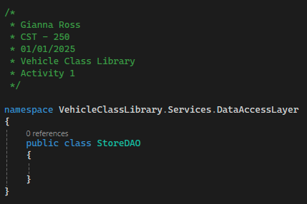

Figure : Public StoreDAO class

1. Add two private lists of type VehicleModel to the StoreDAO, one for the inventory and one for the shopping cart. You may need to add a using statement for VehicleClassLibrary.Models. Using the VehicleModel class instead of any of the more specific models showcases the OOP pillar of polymorphism. Our inventory and shopping cart lists will be able to hold data of the VehicleModel type as well as any classes than extend the model, such as the CarModel, the MotorcycleModel, and the PickupModel. We also need to add a string to specify the directory and name of the inventory text file as shown in Figure 43 as well as a string to hold the full file path. Since these fields are private, they should be in _camelCase, the C# naming convention for private variables. To find the text file after it has been created, you will have to navigate to your project then follow bin > Debug > net8.0 to find the Data folder.

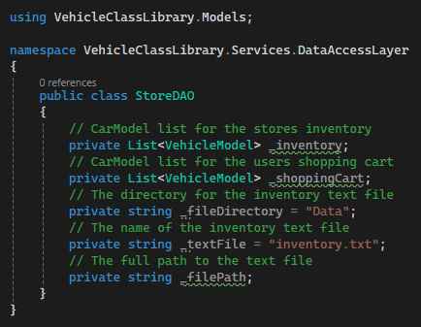

Figure : StoreDAO with inventory and shopping cart lists and inventory file location strings

1. Create a default constructor for StoreDAO. We will use this to initialize the VehicleModel lists and set up the _filePath variable as shown in . Not assigning the lists will result in a Null Reference Exception run-time error. We use Path.Combine for the file path so that the path is in the correct format without manual formatting. Additionally, we can get the location we are currently in using AppDomain.CurrentDomain.BaseDirectory.

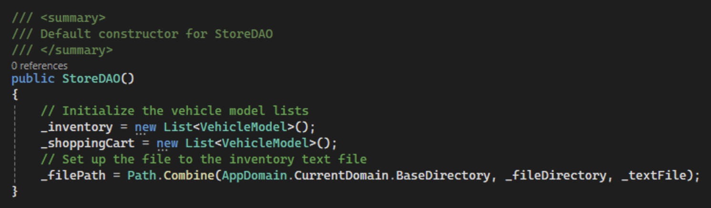

Figure : Default constructor for the StoreDAO

1. We should create two methods to return the VehicleModel lists, as shown in . This will allow us to see the VehicleModels in the inventory and shopping cart later. The naming convention for methods is PascalCase, so these methods will be named GetInventory and GetShoppingCart.

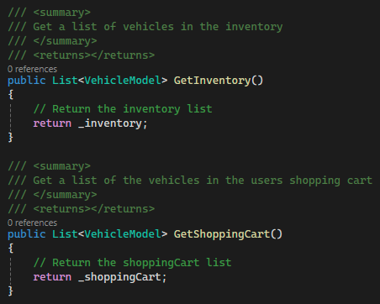

Figure : Adding methods to return the inventory and shopping cart lists



* Run the xUnit tests for these two methods.
* Take a screenshot of the xUnit test results.
* Paste the images into a Microsoft Word document.
* Put a caption below each image explaining what is being demonstrated.

1. Create a method named AddVehicleToInventory to add a new VehicleModel to the inventory as shown in . We can use the number of items in the inventory list to set the id of the new VehicleModel. This will start the VehicleModel IDs at 1. This application will not have a delete feature, so we can guarantee that the _inventory.Count + 1 will always create a new id. Additionally, we can use the id as a return for the method.

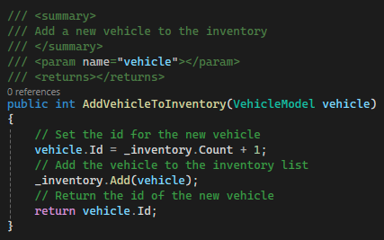

Figure : Method to add a new VehicleModel to the inventory



* Run the xUnit tests for this method.
* Take a screenshot of the xUnit test results.
* Paste the images into a Microsoft Word document.
* Put a caption below the image explaining what is being demonstrated.

1. We also need a method named AddVehicleToCart to add a VehicleModel to the cart based on the VehicleModels id and the inventory list as shown in . This will be done by looping over the inventory, looking for the correct id so that we can add that VehicleModel to the cart. We will then return the number of items in the shopping cart.

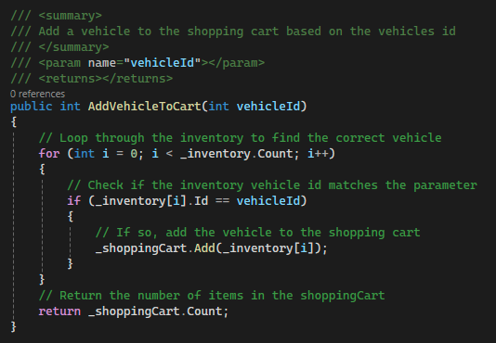

Figure : Method to add a VehicleModel to the cart based on id.



* Run the xUnit tests for this method.
* Take a screenshot of the xUnit test results.
* Paste the images into a Microsoft Word document.
* Put a caption below the image explaining what is being demonstrated.



* Commit all changes in the project to source control.
* Commit Message: Add the vehicle model, get methods for the inventory and shopping cart lists, and methods to add vehicles to the inventory and shopping cart.

1. Additionally, we need to add a method to the DAO to write the inventory to a text file as shown in . Create a new method named WriteInventory that returns a bool and add a summary and end-of-method comment. This will allow us to easily keep track the closing curly brace for the method.

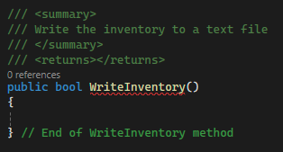

Figure : Setting up the WriteInventory method

1. First, check if the directory (folder) for the text file exists. If it doesn't, create the directory to store the inventory.txt file. We also need to create a new StreamWriter object using the _filePath string to write text to the file. We put this instantiation inside a using statement so that .NET will clean up the resources and act as a garbage collector for the StreamWriter as shown in . We should also use a try-catch block to handle any possible errors from the StreamWriter. While it is normally good practice to put only one line of code in a try block, the using statement makes it necessary to surround the entire using block with the try-catch. If there are errors writing to the file, we will return false.

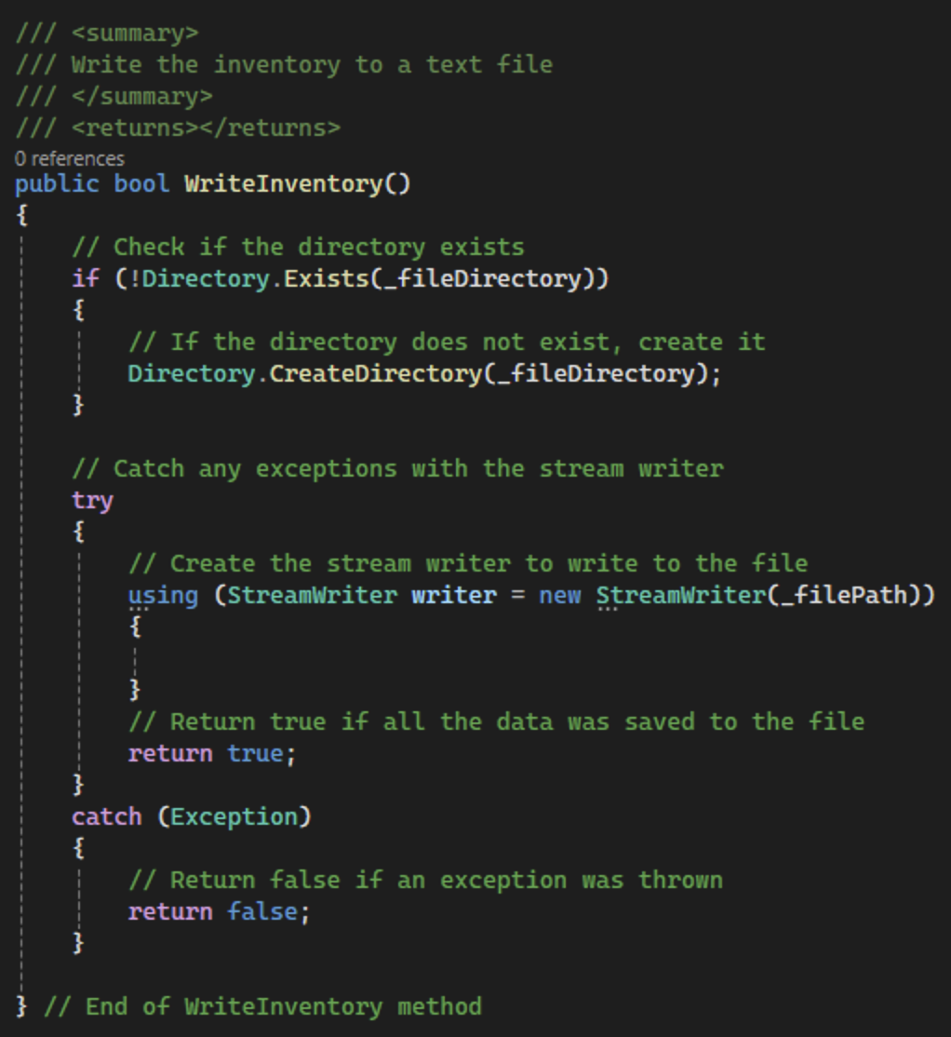

Figure : Creating the directory and creating a StreamWriter object.

1. Finally, we can loop through the VehicleModels in the inventory list and use the GetType method to get the type of each vehicle. Create a switch statement using the Name property of the type to save the correct data for each vehicle. We can use string interpolation to format the VehicleModels to send to the text file, as shown in . The first piece of data in each line will be the type of the model so we can correctly read the data later. We will not send the id to the file, as it will be generated when vehicles are being read from the file. We can use the WriteLine method in the stream writer to write the string to the file. If all went well, we should return true to mark that the inventory is now in the file.

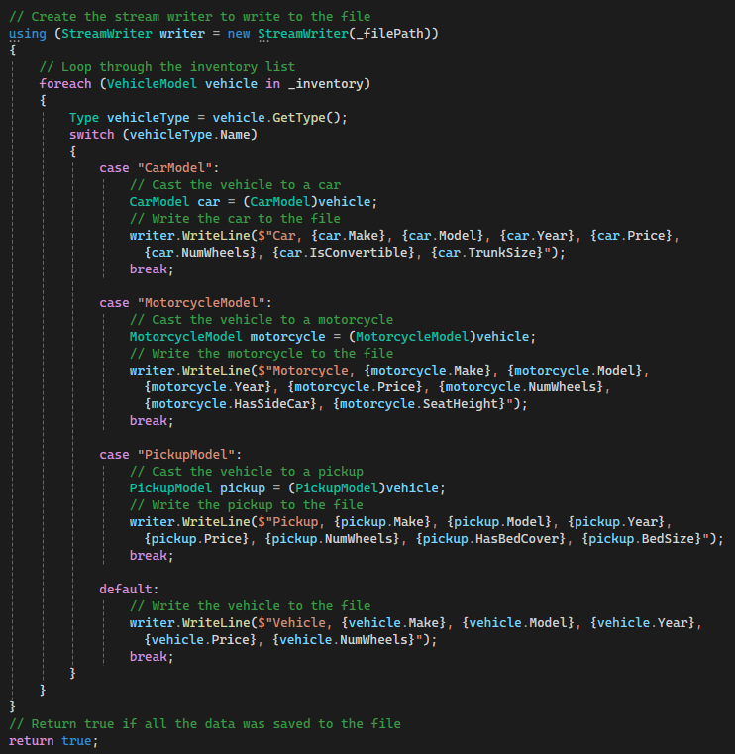

Figure : Method to write the inventory list to inventory.txt

1. Next, we need to add a method to read an inventory from the text file. Create a new method named ReadInventory that will return a list of VehicleModel objectsm as shown in . Add a summary and end-of-method comment to the new method.

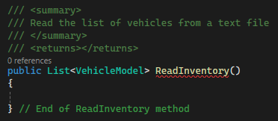

Figure : ReadInventory method with a summary and end-of-method comment

1. Because we will need to parse several types of data to read the inventory from our text file, we will begin by creating three methods to safely parse integers, decimals, and Booleans. First, create a private ParseInteger method with a summary comment that accepts a string and will return the parsed integer or a 0 if an exception occurs, as shown in . It is important to only put one line of code in a try-catch block. This allows you to handle exceptions for each line on an individual basis rather than having more general, catch-all exception handling.

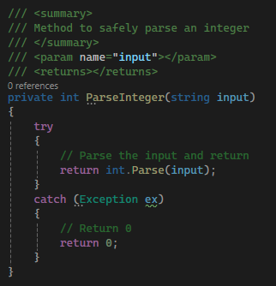

Figure : ParseInteger method to safely parse ints

1. Create two more private methods named ParseDecimal and ParseBoolean to have the same functionality as the ParseInteger method, as shown in . Remember to add summary comments to both methods.

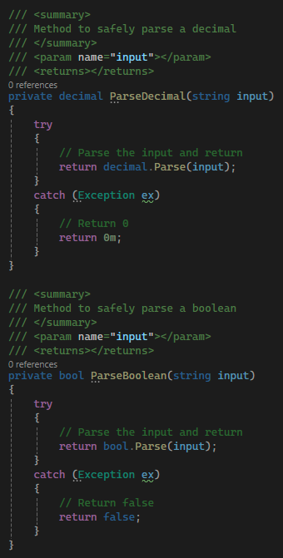

Figure : Methods to safely parse decimals and Booleans

1. Back in the ReadInventory method, declare variables for each of the vehicle properties as well as a nullable string to hold each line as it is read from the file and a string array to hold the split vehicle parts. Then, check if the file exists and set up a try-catch for the StreamReader object that will be created within another using statement as shown in . If an exception occurs while reading the file, we should return the inventory list as is. We will return the full inventory list from the method.

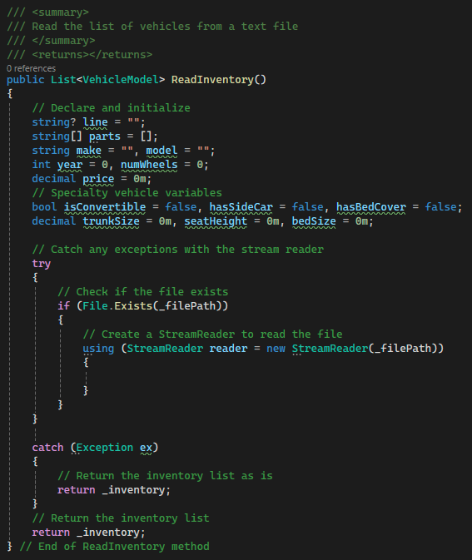

Figure : Setting up the ReadInventory StreamReader.

1. Next, use the StreamReader's ReadLine method to read each line from the file. If the read line is null, the file has run out of lines. Then we can use the Split method to split the read line and parse the year, price, and number of wheels for each vehicle as shown in .

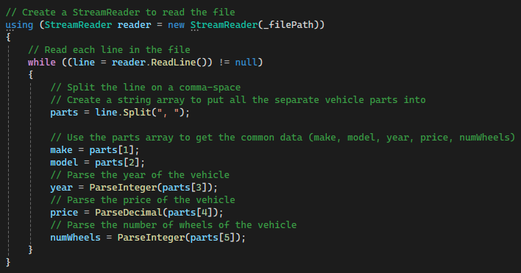

Figure : Parsing the common data in the ReadInventory method.

1. Using the first piece of read data, we can then check if the current vehicle is specialized. If it is, parse the rest of the specialty data depending on the specific vehicle type. Using the gathered information, create a new model and call the AddVehicleToInventory method we created earlier so the id can be generated as shown in .

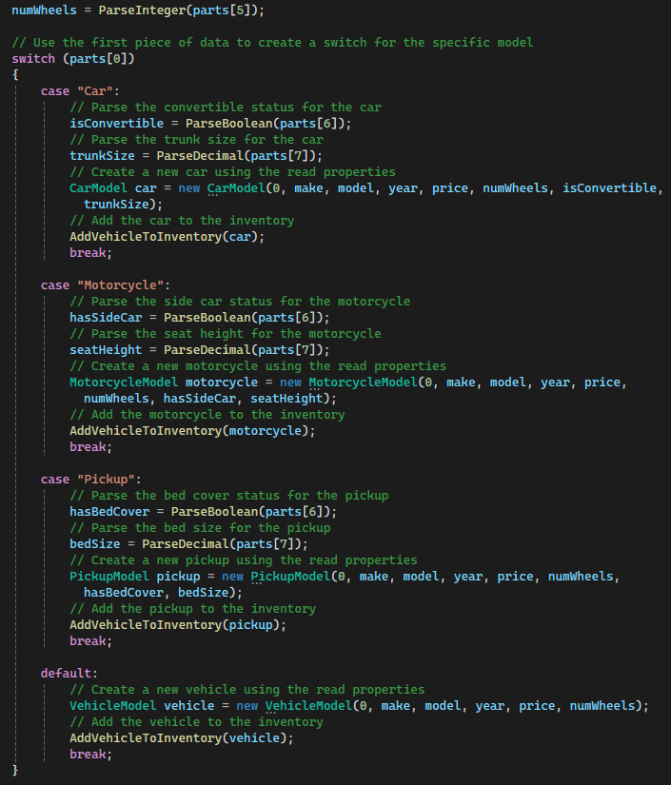

Figure : Finishing the ReadInventory method in the StoreDAO.

1. To complete the DAO, create a method called Checkout that will calculate the total value of items in the shoppingCart list and empty the list as shown in . This will be done by looping through the list and adding the cost of each VehicleModel to a variable. We can then clear the shopping cart of all items and return the total cost.

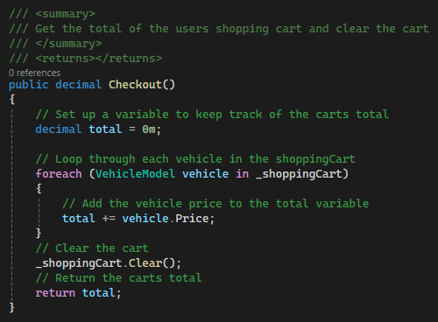

Figure : Checkout method



* Run the xUnit tests for this method.
* Take a screenshot of the xUnit test results.
* Paste the images into a Microsoft Word document.
* Put a caption below the image explaining what is being demonstrated.



* Commit all changes in the project to source control.
* Commit Message: Complete the DAO with read, write, and checkout methods.

1. Next, we need to create a business logic layer class for our application. This class will reference and send data between the data access layer and the presentation layer. This layer can also contain calculations and other logic rules for an application. In the BusinessLogicLayer folder, create a class named StoreLogic and set its access specifier to public as shown in . Add a citation to the top of the class.

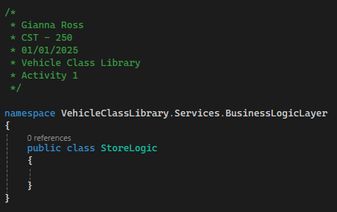

Figure : Creating the StoreLogic class.

1. Create a class level, private StoreDAO variable named _storeDAO in the new class as shown in . This will allow us to make calls to the methods we just created in the data access layer. We will also need a default constructor for StoreLogic so that we can initialize the _storeDAO variable.

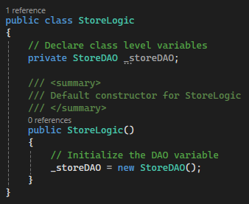

Figure : Declaring and initializing a StoreDAO variable.

1. We will also need to create a StoreLogic method for every StoreDAO method we created so we can use them in the presentation layer. While this may seem unnecessary, it creates a layer for rules, calculations, and other logic that is outside the data access and presentation layers. Create two methods in the StoreLogic class to return the inventory and shopping cart lists as shown in .

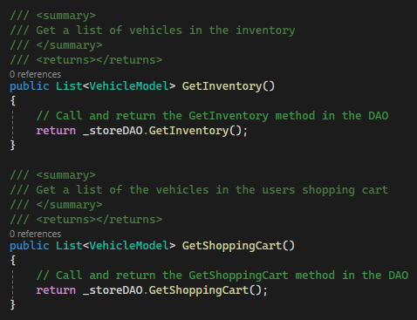

Figure : Business logic layer methods to get the inventory and shopping cart from the DAO.

1. Next, create two more methods that will add VehicleModels to the inventory and shopping cart lists in the data access object as shown in . These methods will have the same parameters and return types as the DAO methods.

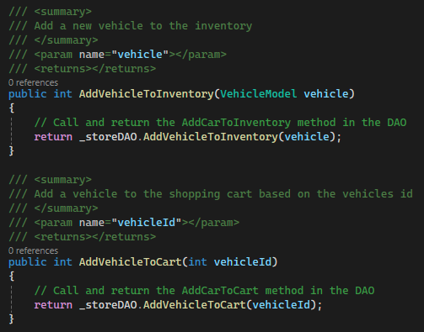

Figure : Methods to add VehicleModels to the inventory and shopping cart

1. We also need two methods to read and write the inventory using a text file as shown in . These methods will also mirror the data access layer methods.

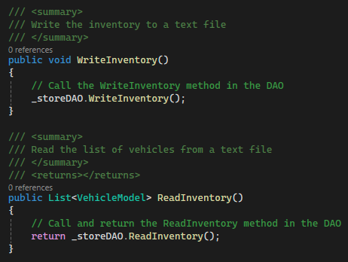

Figure : Business logic layer methods for reading and writing inventory

1. Finally, create a method in StoreLogic named Checkout that will call the Checkout method in the DAO as shown in Figure 63.

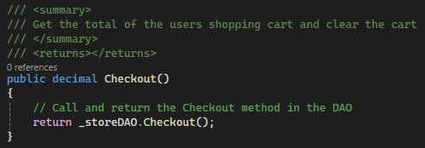

Figure : Checkout method in the business layer



* Commit all changes in the project to source control.
* Commit Message: Add the StoreLogic class to pass data to and from the DAO and presentation layers.



* Take a screenshotscreenshot of the citations for VehicleModel, CarModel, MotorcycleModel, PickupModel, StoreDAO, and StoreLogic. Make sure to include the class declarations in the images.
* Take a screenshotscreenshot of the VehicleModel, CarModel, MotorcycleModel, PickupModel, StoreDAO, and StoreLogic constructors (default and parameterized).
* Take a screenshotscreenshot of the VehicleModel, CarModel, MotorcycleModel, and PickupModel ToString methods.
* Take a screenshotscreenshot of the GetInventory, GetShoppingCart, AddVehicleToInventory, AddVehicleToCart, WriteInventory, ReadInventory, ParseInteger, ParseDecimal, ParseBoolean, and Checkout methods in StoreDAO.
* Take a screenshotscreenshot of the GetInventory, GetShoppingCart, AddVehicleToInventory, AddVehicleToCart, WriteInventory, ReadInventory, and Checkout methods in StoreLogic.
* Take a screenshotscreenshot of the UMLs for the VehicleModel, CarModel, MotorcycleModel, PickupModel, StoreDAO, and StoreLogic classes.
* Paste the images into a Microsoft Word document.
* Put a caption below each image explaining what is being demonstrated.

# Part 3 – Console Application

In this section, we will create an application that will utilize the class library we just created to create a console-based application.

1. In the VehicleClassLibrary project, right-click on the solution and add a new project as shown in . Create a new Console App project named VehicleStoreConsoleApp as shown in .

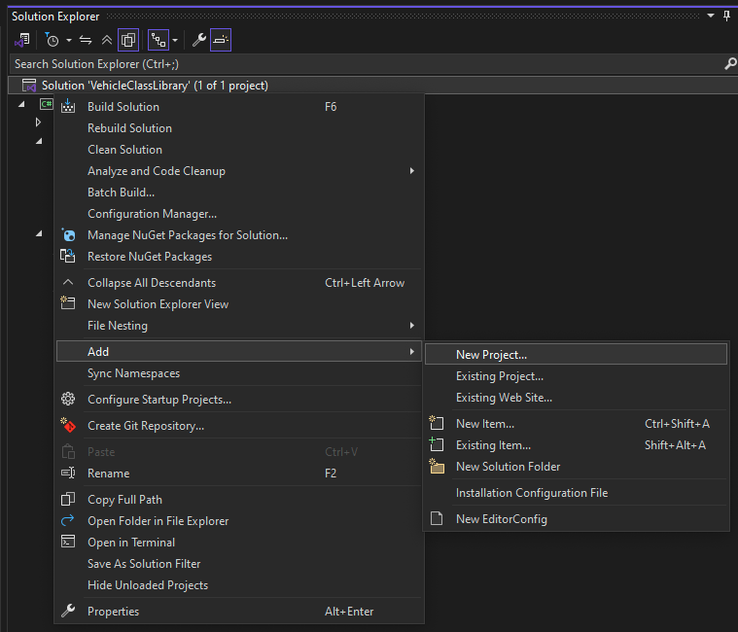

Figure : Right-click on the solution to add a new project.

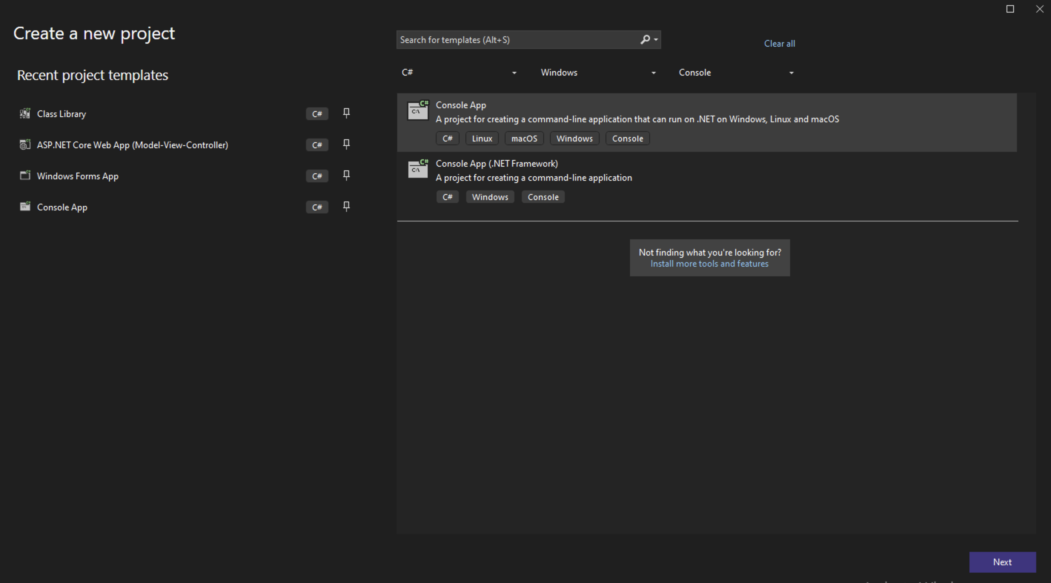

Figure : Creating a new console app.

1. In the Additional Information page, unselect "Do not use top-level statements," as shown in . This means the main method will not be explicitly defined in the program. shows what the solution explorer should look like after the new project is created.

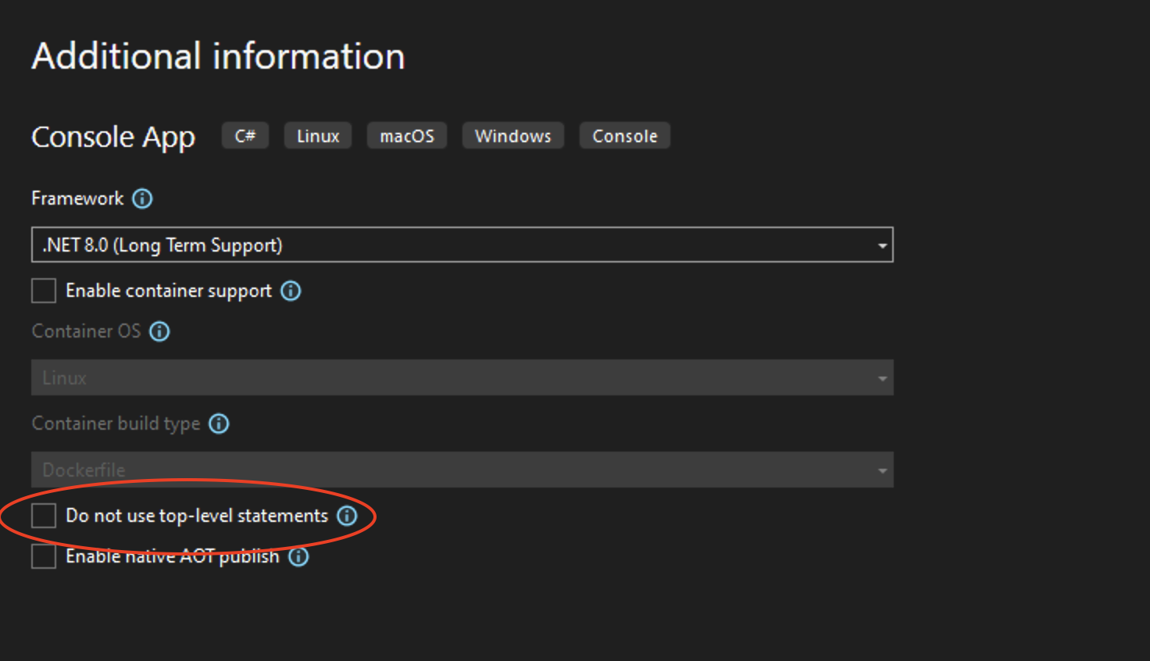

Figure : Uncheck "Do not use top-level statements."

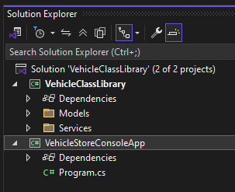

Figure : Solution explorer with two projects

1. Because the class library has no main method, it is not a runnable project and will error if you attempt to run it as shown in . So, we need to set the startup project to the console app. Right-click the VehicleStoreConsoleApp and select "Set as Startup Project," as shown in .

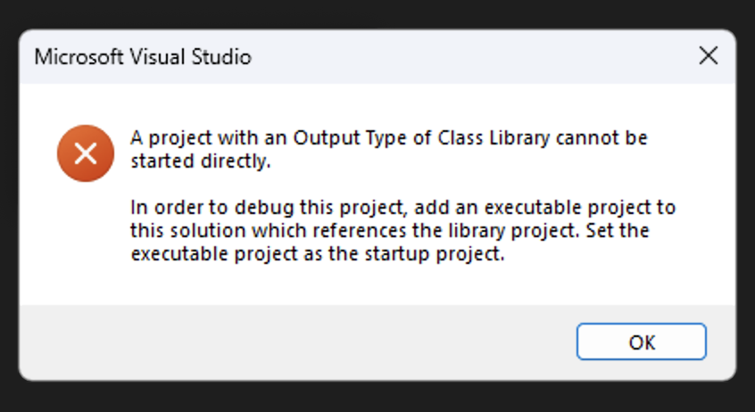

Figure : The error shown if the class library is run.

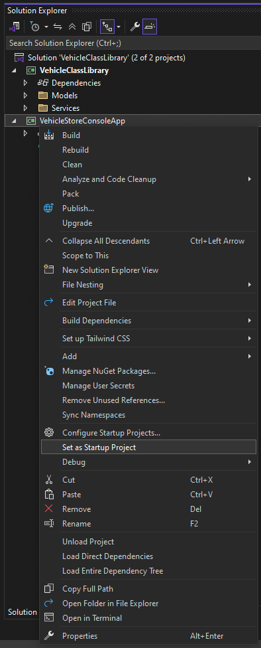

Figure : Setting a new startup project.

1. Now, if we run the program, we should see the "Hello, World!" message from our Program.cs file, as shown in .

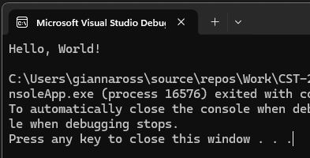

Figure : Console running after startup project is configured.

1. If we were to try to create a StoreLogic variable in the VehicleStoreConsoleApp's Program.cs file, it would generate the error shown in . This is because there is no link between our VehicleClassLibrary and our new console app. To fix this, we can add a project reference by right-clicking on the VehicleStoreConsoleApp and choosing Add, then Project Reference as shown in . Check the VehicleClassLibrary project in the Reference Manager as shown in and select OK.

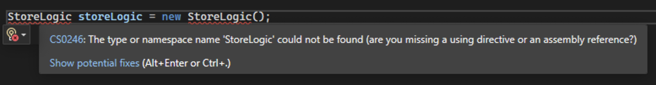

Figure : Error occurred without project reference.

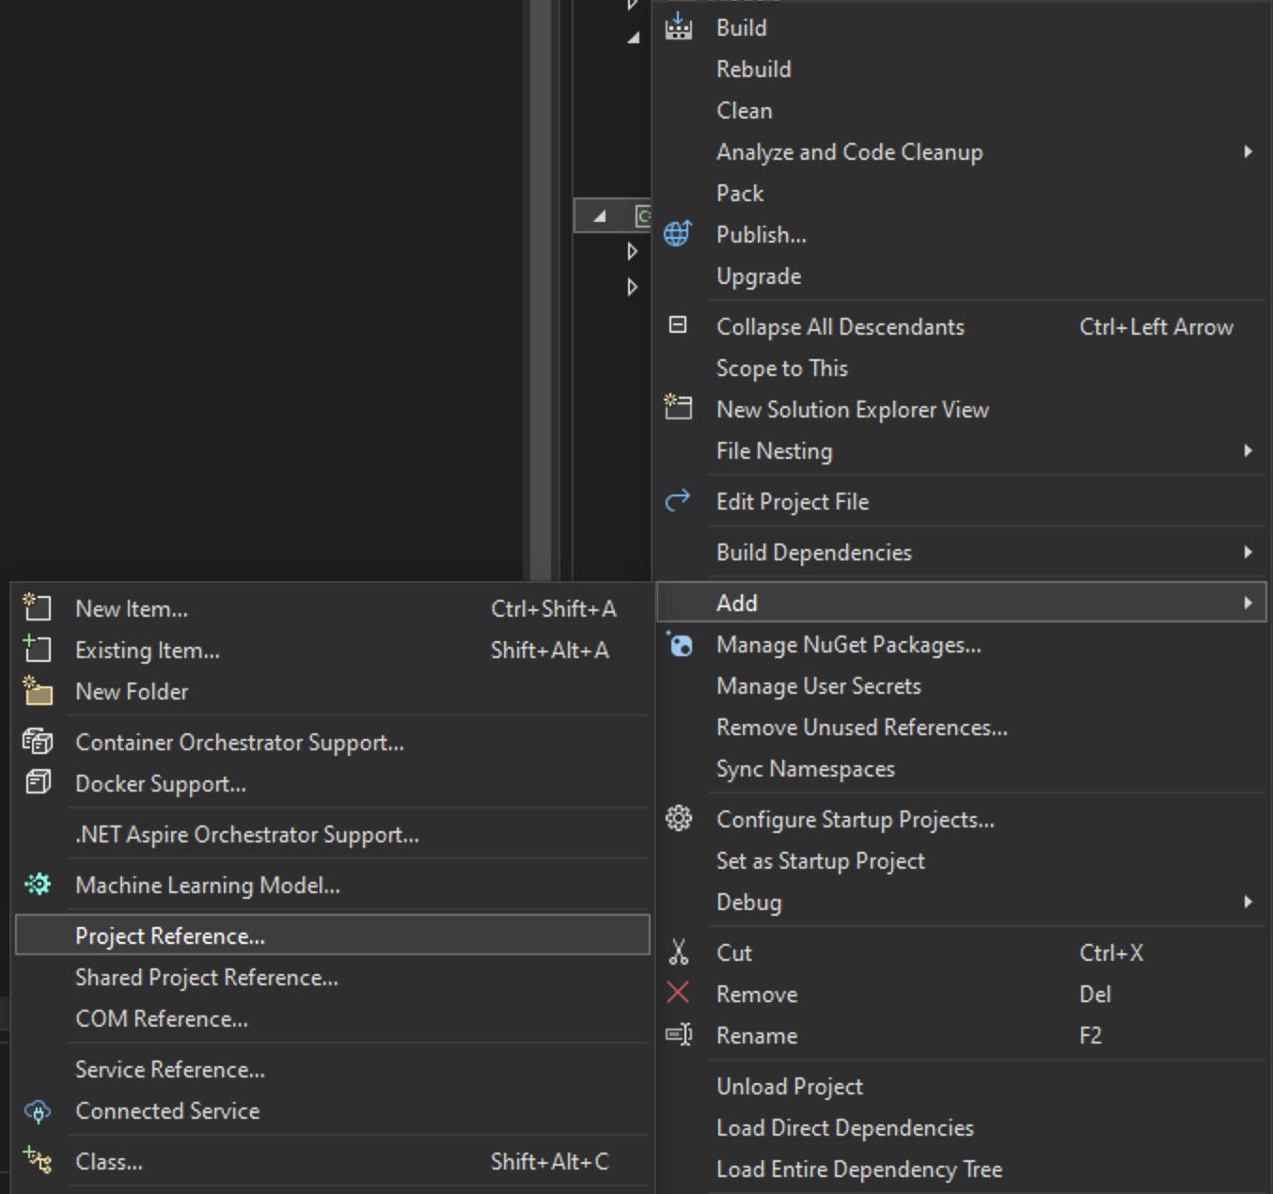

Figure : Adding a project reference to the VehicleStoreConsoleApp.

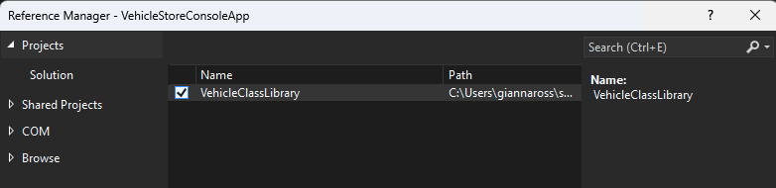

Figure : Add a project reference to the VehicleClassLibrary in the Reference Manager.

1. Now, we can add a reference to the StoreLogic class without errors. You may still need to add a using statement for the VehicleClassLibrary BusinessLogicLayer folder as shown in and 75.

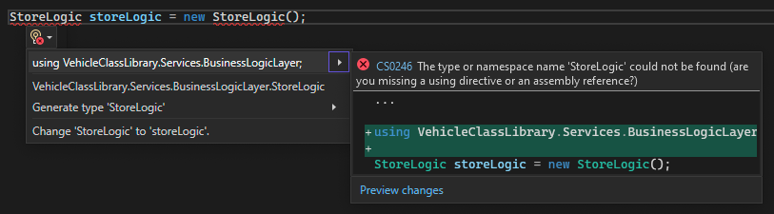

Figure : Adding a reference to VehicleClassLibrary.Services.BusinessLogicLayer.

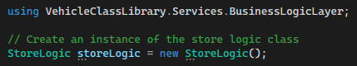

Figure : StoreLogic instance with using statement

1. Remove the storeLogic variable for now, as we will create and use it later in the Program.cs file. We should start our program by showing the user a welcome message, as shown in . We can also add comments to mark where the code for our main method should go. Make sure to add a citation to the top of the class.

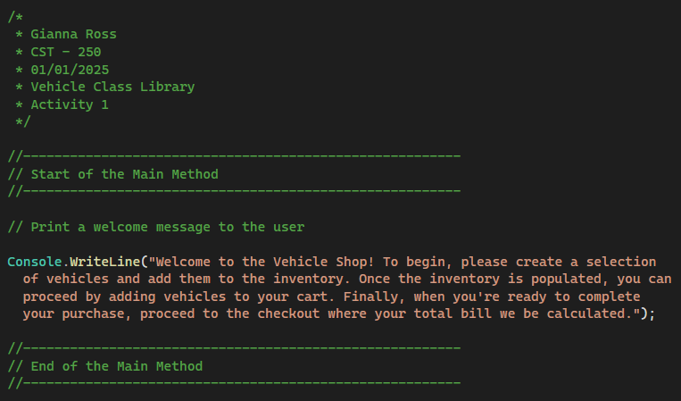

Figure : Print a welcome message to the user.

1. Since we have no main method, other functions will be created with the static keyword instead of the traditional public/private identifier. These blocks of code are known as functions instead of methods since they are not contained in a class. Since these are local functions, we cannot use the traditional /// summary comments, so we will use normal comments instead to summarize the functions.

The first function we will need will read an integer input from the user based on a given list of action options. Create a new function named ReadChoice that will return an int. Start by declaring and initializing a string for the users input and an int choice for the return result of the method. Then, create a while loop based on the choice being -1. This will allow us to prompt the user until they input a valid choice. Print the options to the user and use the Console.ReadLine method to get the input given, as shown in . Using Console.Write instead of Console.WriteLine allows the user to enter their option on the same line as the end of our print statement.

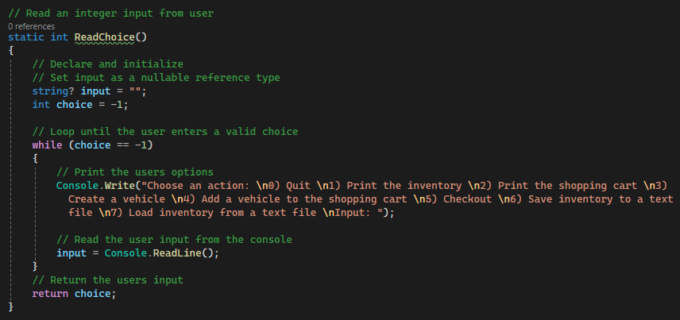

Figure : Setting up the while loop to read the user's input.

1. Make sure the user entered a value and use the int.Parse method to attempt to parse the input to an integer. Because this method is very likely to cause an exception, we will surround it in a try-catch block. We will also create three catch blocks for the int.Parse, two for the most common exceptions and one for anything else, as shown in .

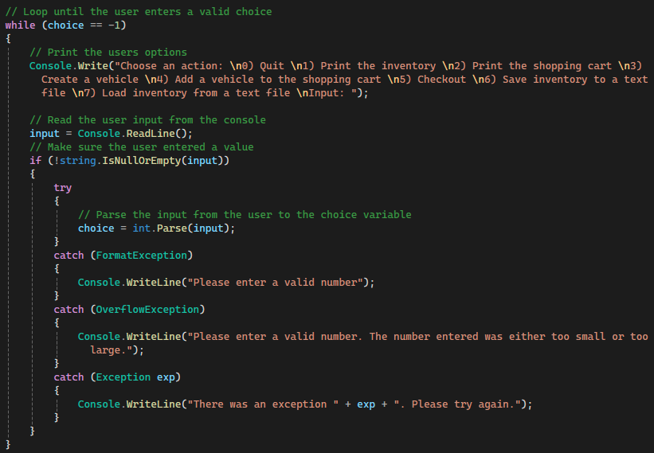

Figure : Parsing the user's input and catching all exceptions.



* Commit all changes in the project to source control.
* Commit Message: Add a Console app with a welcome message and ReadChoice method.

1. Next, we need to add a control loop for the user with summary and end-of-method comments. To keep the main method clean, this will be in a separate function, using a while loop and reading input from the console. First, create a new static function named ControlLoop with no return. Then, declare a new StoreLogic variable and create variables to hold various inputs from the user including an int choice, id, year, and numWheels, a string make and model, a decimal price and total, the specialty properties for the car, motorcycle, and pickup models, a list of VehicleModels vehicleList, and a VehicleModel vehicle as shown in .

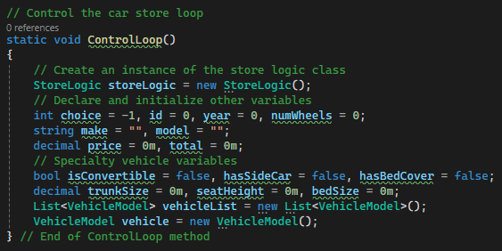

Figure : Setting up variables for the ControlLoop function.

1. We can use a while loop and a switch statement to run our vehicle store program. The while loop will allow the program to continue until the user enters a 0 and the switch statement allows for easier handling of the user's choice by creating cases 0–7, as shown in . Case 0 will print an exit statement, and the while loop will not continue, so the program will end. The default case tells the user that his/her input was not valid. This will then loop back to the ReadChoice method so that he/she can select a new number.

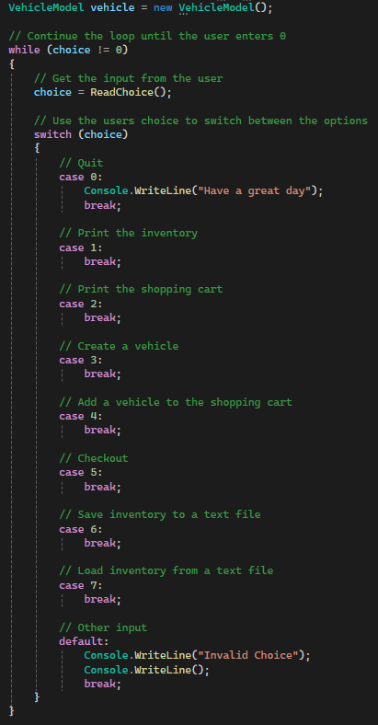

Figure : Setting up the while loop and switch statement for the control loop.

1. Case 1 will print the inventory list from the business logic layer. This will be done by making a call to get the inventory list and saving the result to the vehicleList variable. Then, print each VehicleModel to the console as shown in . Even though the variable is a VehicleModel, each item in the vehicle list will be printed based on the specific ToString we created earlier. This is another use of polymorphism, as we don't have to check what type of vehicle we are dealing with.

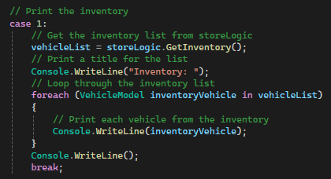

Figure : Printing the inventory list

1. Case 2 will print the shopping cart list to the console. Like the inventory list, we will store the result of a method call to the business logic layer in the vehicleList and print out each VehicleModel using a foreach loop as shown in .

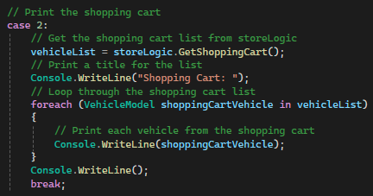

Figure : Printing the shopping cart list

1. Case 3 will create a new vehicle. This will be done by reading each value for a standard VehicleModel as well as the specified type of vehicle and storing it in the vehicle variable and then calling the AddVehicleToInventory method for the vehicle object. We will begin by getting the type of vehicle and the common vehicle properties from the user as shown in .

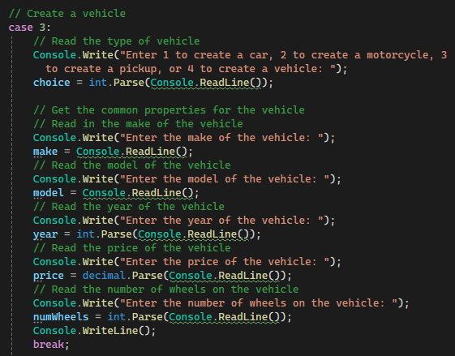

Figure : Logic to get the common vehicle properties from the user

1. Next, use the user's entered choice to get the vehicle-specific properties and create the new vehicle. Because the car, motorcycle, and pickup models all inherit from the VehicleModel, we can store any of the vehicles in the vehicle variable. Finally, add the vehicle to the inventory using the store logic object as shown in .

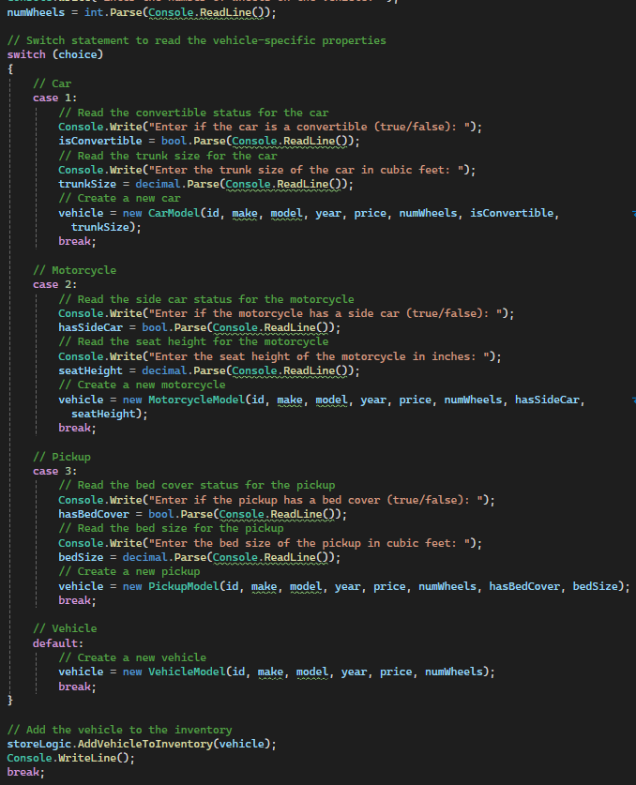

Figure : Get the vehicle-specific properties and add the vehicle to the inventory.

1. Case 4 will add a VehicleModel to the shopping cart based on the VehicleModel's id. This will use the AddVehicleToCart method from the VehicleClassLibrary and a Console.ReadLine as shown in .

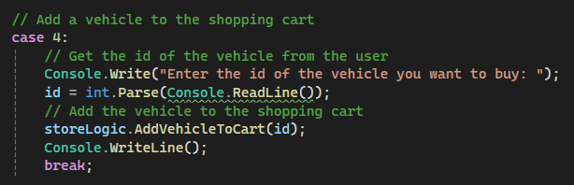

Figure : Adding a VehicleModel to the shopping cart

1. Case 5 will allow the user to checkout using the StoreLogic method we wrote earlier as shown in . We will also print the user's total.

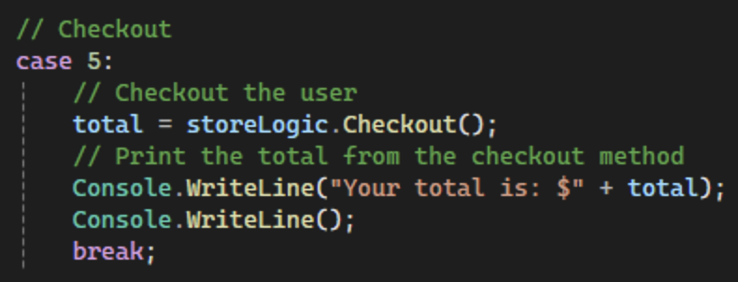

Figure : Checking out the user

1. Case 6 will write the inventory list to the text file as shown in . This will use the WriteInventory method from the business logic layer.

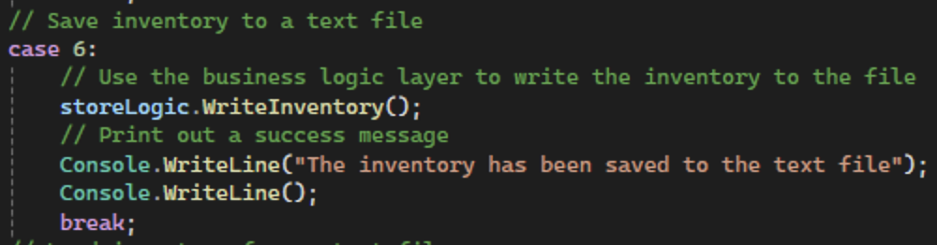

Figure : Writing the inventory to the text file

1. Case 7 will allow the user to read a previously saved inventory from the text file using the ReadInventory method as shown in .

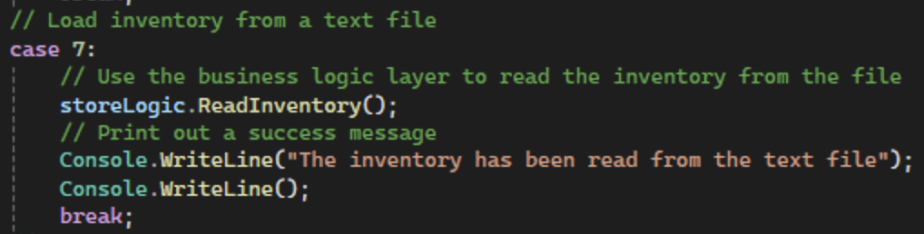

Figure : Reading an inventory from the text file

1. Now that our control loop function is complete, we can call it from our main method as shown in so that our program will run.

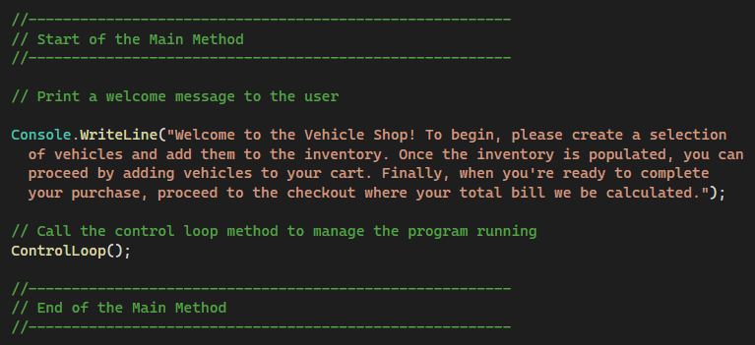

Figure : Main method with control loop function call



* Commit all changes in the project to source control.
* Commit Message: Finish the Console app with the ControlLoop method.



* Take a screenshotscreenshot of each case of the switch statement running (9 total).
* Take a screenshotscreenshot of the citation for Program.cs.
* Take a screenshotscreenshot of the main, ReadChoice, and ControlLoop functions.
* Take a screenshotscreenshot of the UML for the Program.cs class.
* Paste the images into a Microsoft Word document.
* Put a caption below each image explaining what is being demonstrated.

## **Console App Challenges**

Add the following features to the program:

1. **Two new properties** – Invent two new properties for your VehicleModel. You can use things like Color (string), Miles (integer), IsNew (Boolean), SizeOfEngine (decimal), BodyCondition (integer), FuelType (string), etc. Make the necessary property changes in the VehicleModel.cs file, as well as the rest of the program, to accommodate the new properties.
2. **Error Checking** – The console application has potential crashing points where a user can input strings in places where numbers are expected. The int.Parse (input string) method will cause exception faults unless you check the values before attempting the type conversion. Research "Try Catch C#" in Google to get some help. The user can also select numbers that are out of range of a list. Try putting VehicleModel number 99 into your shopping cart and see what happens. Fix these errors so the program displays a message instead of simply crashing.

* Commit the challenges to source control with a commit message.



* Take a screenshot of the application running after the new features have been added.
* Take a screenshot of each method added or updated to implement the features.
* Take a screenshot of the updated UMLs for any classes with added methods.
* Paste the images into a Microsoft Word document.
* Put a caption below each image explaining what is being demonstrated.

# Part 4 – GUI Vehicle Store

In this section, we are going to build a graphic user interface (Windows forms app) that will have the same actions as the console app. Additionally, this section will outline good software design principles for form-based applications.

1. Add a new project to the solution by right-clicking the VehicleClassLibrary solution and choosing Add > New Project… as shown in .

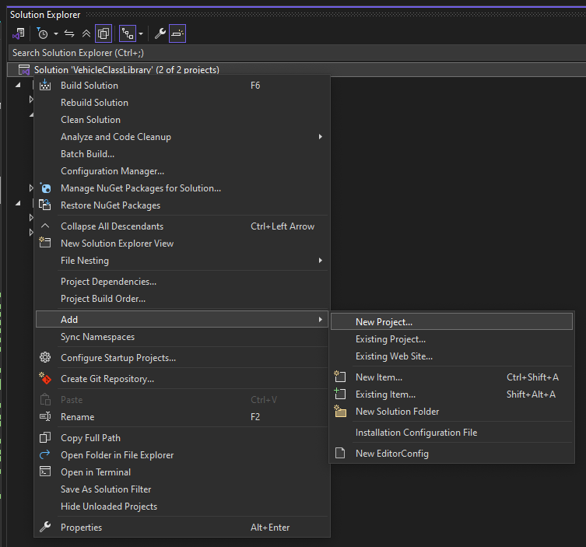

Figure : Adding a new project to the solution

1. Create a new Windows Forms App as shown in . Make sure to not select Windows Forms App (.NET Framework) as it is for a previous version of .NET and will be incompatible with the previous projects. Name the project VehicleStoreGUIApp as shown in and create the new application.

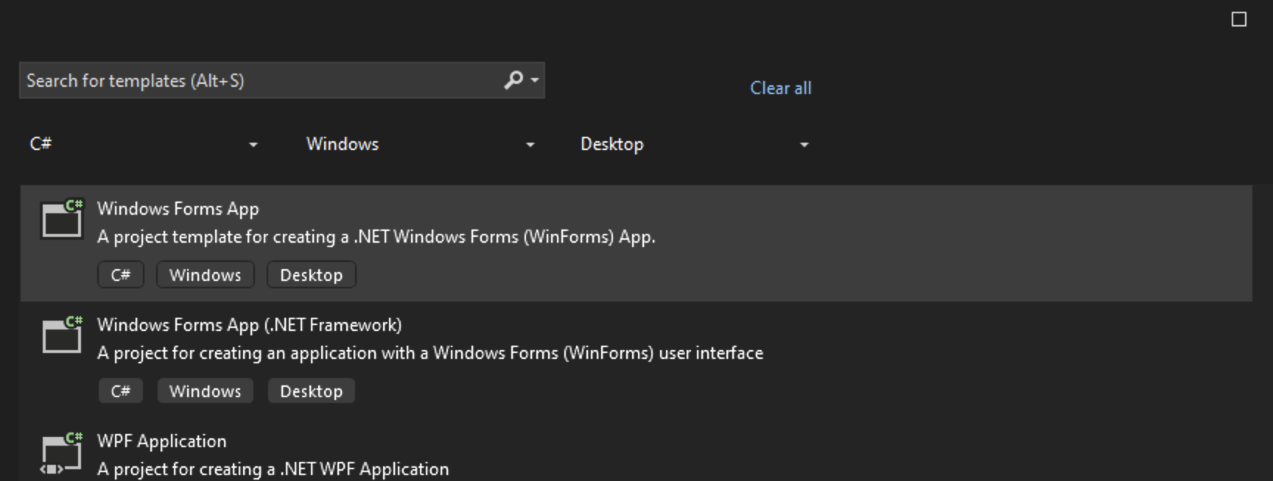

Figure : Creating a new Windows Forms App

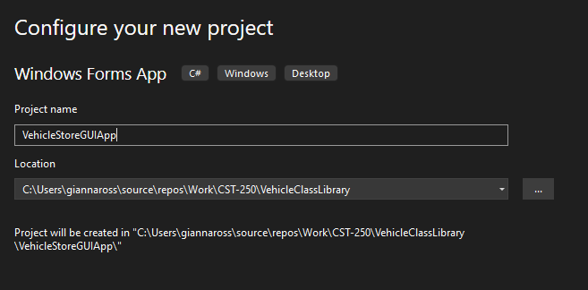

Figure : Configuring VehicleStoreGUIApp

1. We should now have a blank form titled Form1 as shown in . It is good practice to rename forms and controls so they reflect their purpose, so we will begin by renaming Form1. Right-click on Form1.cs in the solution explorer and click rename as shown in . We will change Form1 to be FrmVehicleStore as shown in Figure 95 since "Frm" is the naming convention for forms. If the option appears, click yes to rename all references.

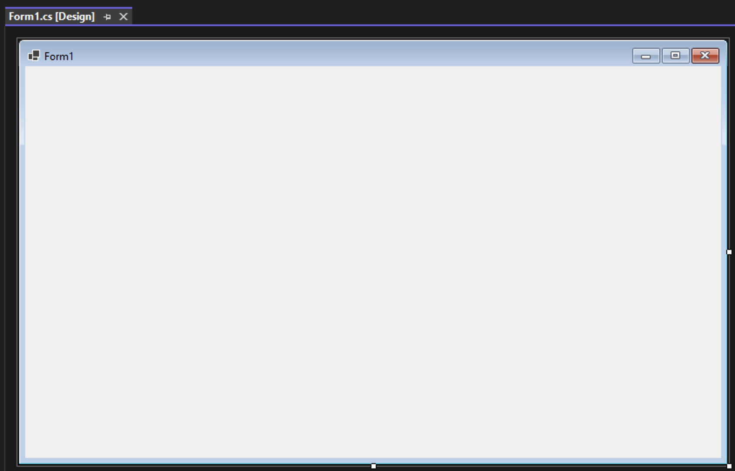

Figure : Blank Form1

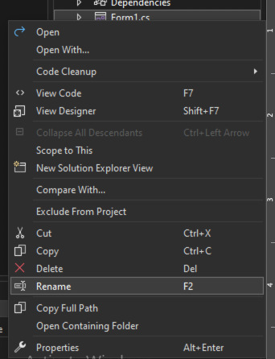

Figure : Renaming a form

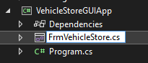

Figure : Form1 is renamed to FrmVehicleStore

1. Next, we will change the text of the form from Form1 to "Vehicle Store." Select the form and navigate to the properties section. Find the Text property as shown in and change the text to "Vehicle Store" as shown in . The top left of the form should now match .

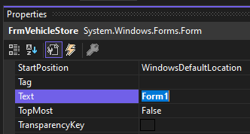

Figure : Text property with Form1

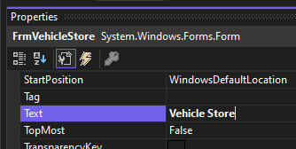

Figure : The updated Text property with Vehicle Store

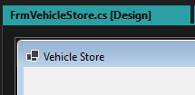

Figure : FrmVehicleStore with updated text

1. On the Vehicle Store Form, we will need a variety of different controls. First, we will add, name, and label the controls to create a standard VehicleModel. Start by adding a GroupBox control to the form and resizing it to match .

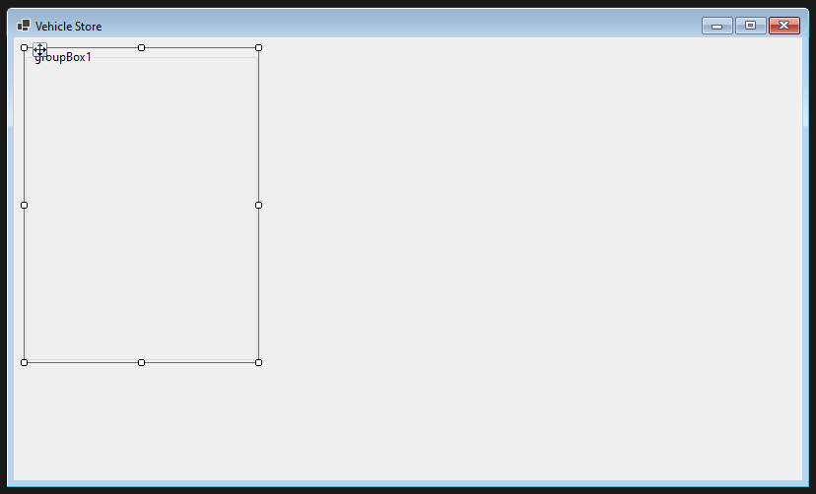

Figure : Vehicle Store Form with GroupBox control

1. Like the form, we can change the text for the group box by going to the properties tab and updating the Text property. We will change the text to "Create a Vehicle." Then, add 4 radio buttons into the group box. Change the Text of each to "Car," "Motorcycle," "Pickup," and "Vehicle" respectively, as shown in . These buttons will allow the use to choose which type of vehicle to create.

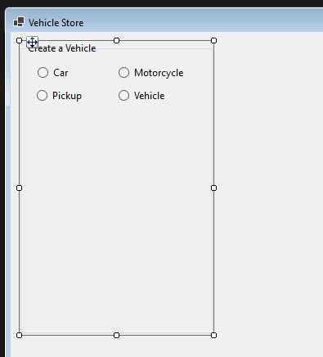

Figure : Radio buttons for vehicle selection

1. Using the Name property, we can set the name for each radio button as shown in . This will allow us to interact with the radio buttons in our backend code. The naming convention for radio buttons is rdo, so we will name the buttons rdoCar, rdoMotorcycle, rdoPickup, and rdoVehicle.

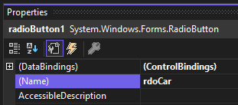

Figure : Naming a radio button

1. Then, we can add 5 labels into the group box and update the text property of each to say "Make:", "Model:", "Year:", "Price:", and "Wheels:" respectively, as shown in .

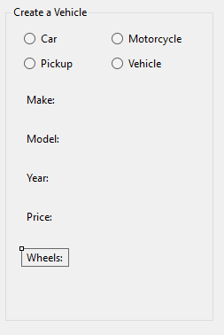

Figure : Create a Vehicle group box with labels.

1. Next, we will add in 5 text box controls, one for each label. Instead of changing the text for these, we will change the name property for each text box as shown in . The naming convention for text boxes is the "txt" prefix. The textboxes for our VehicleModel attributes will be txtMake, txtModel, txtYear, txtPrice, and txtWheels. Lastly, we can add in a button to the group box. We will need to update the text and name properties of the button. The text should be "Create." The naming convention for buttons is the "btn" prefix, so the name will be btnCreate. The final group box should look like .

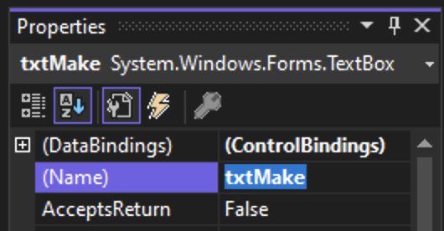

Figure : Changing the name of a text box control

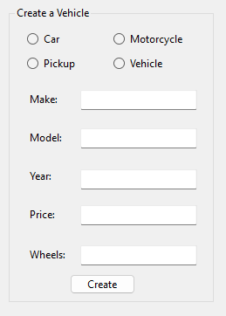

Figure : Final version of the create a vehicle group box

1. We will also need a group box to hold the specialty properties based on the type of vehicle the user wants to create. Start by adding a second group box under the first. Change the Text for the group box to "Specialty Properties" as shown in .

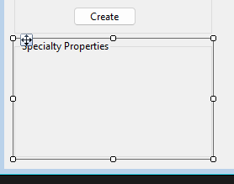

Figure : Specialty Properties group box

1. Add two labels, two radio buttons, and a text box into the group box as shown in . Change the Text for the labels to "Specialty Boolean:" and "Specialty Decimal:". Change the Text for the radio buttons to "Yes" and "No." Finally, rename the radio buttons to rdoSpecialtyYes and rdoSpecialtyNo and the text box to txtSpecialtyDecimal.

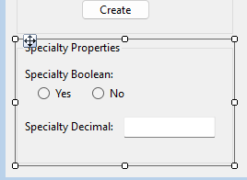

Figure : Completed Specialty Properties group box

1. The next group of controls we need will contain the inventory list. First, place a new GroupBox to the right of the first two and change the text property to "Store Inventory." Next, we will add a ListBox control to the store inventory group box and resize it to take up the entire group box. The naming convention for list boxes is the "lst" prefix, so we will rename the list box to lstInventory. shows the completed group box.

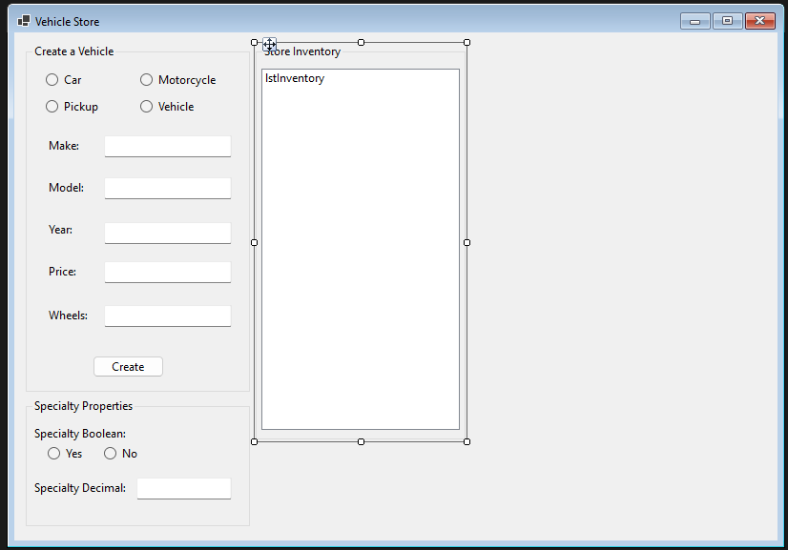

Figure : Vehicle Store form with two complete group boxes

1. Our next step is to add a button to the right of the store inventory group box. This button will be named btnAddToCart and will have "Add to Cart" as its text property as shown in .

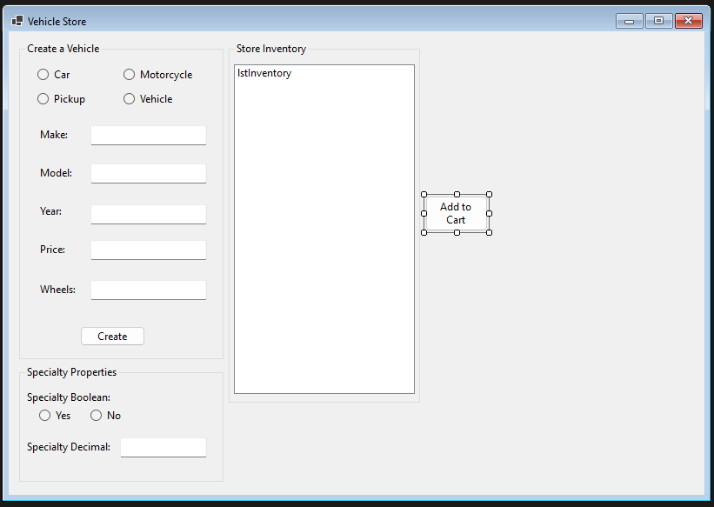

Figure : FrmVehicleStore with add to cart button

1. After we have our button, we need to create another group box and list box to mirror the store inventory. The text for the new group box will be "Shopping Cart" and the name of the new listBox will be lstShoppingCart, as shown in .

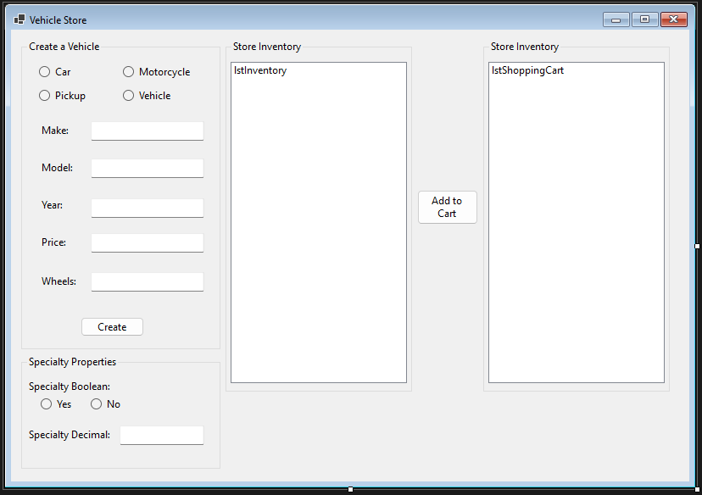

Figure : Vehicle store form with shopping cart group box

1. The next three controls we need are for checking out. These will be a button and two labels below the shopping cart group box as shown in . The button's name will be btnCheckout and will have the text "Checkout." Additionally, the first label will have "Total:" for its text. We can change the text of the second label to "$0" and the name to lblTotal using the "lbl" naming convention for labels.

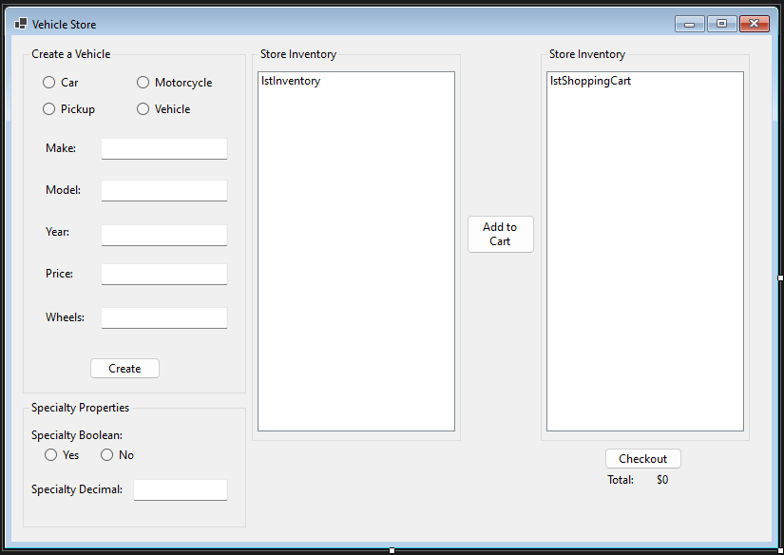

Figure : Completed GUI for the Vehicle Store

1. Finally, we will need error labels for each of our text boxes and radio button sets. These will allow us to show the user if there are issue with the data entered. We will format the first label before creating the rest. Start by adding in a new label beneath the radio buttons in the Create a Vehicle group box. Change the Text of the label to "Please Choose a Vehicle Type" and the Name to lblVehicleTypeError as shown in .

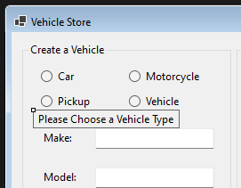

Figure : Creating the Vehicle Type error label

1. Using the ForeColor property, shown in , we can change the font color for our labels to red, under the Web colors tab. This allows the user to quickly see that there is something wrong about the data entered.

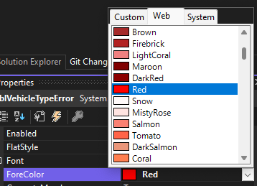

Figure : Changing the ForeColor for the error label to red

1. We can also make the label bold using the font property menu. You can access this menu by selecting the ellipsis in the Font property for the label as shown in . In the font menu, change the font style to bold as shown in and select OK.

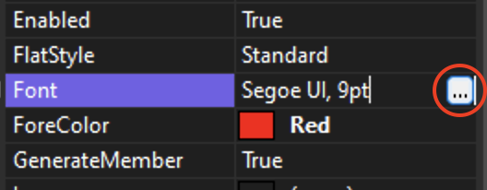

Figure : Opening the Font menu

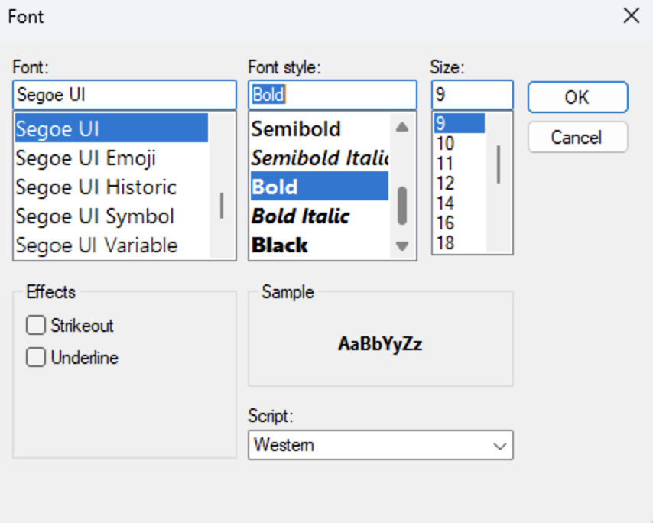

Figure : Changing the font style of the error label

1. Now that we have our first label formatted, we can copy the label and paste it for each text box. Update the name properties of each label to lblMakeError, lblModelError, lblYearError, lblPriceError, lblWheelsError, lblSpecialtyBooleanError, and lblSpecialtyDecimalError, respectively. Additionally, update the text property of each label to reflect .

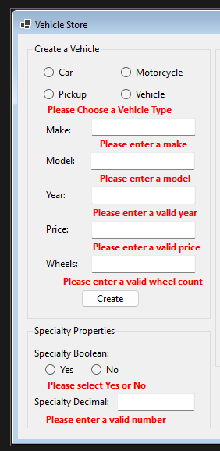

Figure : Create a vehicle and specialty property group boxes with error labels.

1. Next, we need to add a project reference to the VehicleClassLibrary so that the GUI can access the methods we created in Part 1. Right-click on VehicleStoreGUIApp in the solution explorer and select Add > Project Reference as shown in and add a reference to the VehicleClassLibrary as shown in .

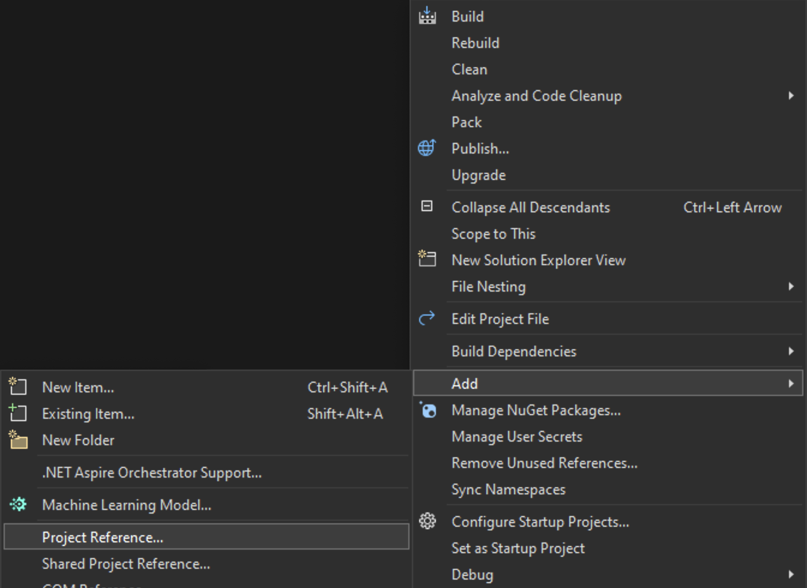

Figure : Adding a project reference to the GUI app

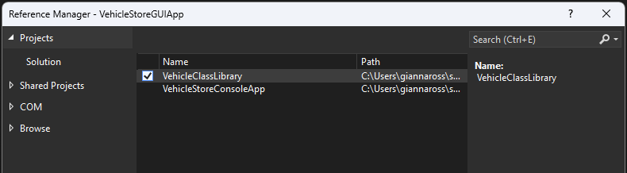

Figure : Adding a reference to the VehicleClassLibrary

1. Change the startup project to the GUI app by right-clicking on VehicleStoreGUIApp and selecting "Set as Startup Project" as shown in . This will allow us to run the GUI application instead of the console app.

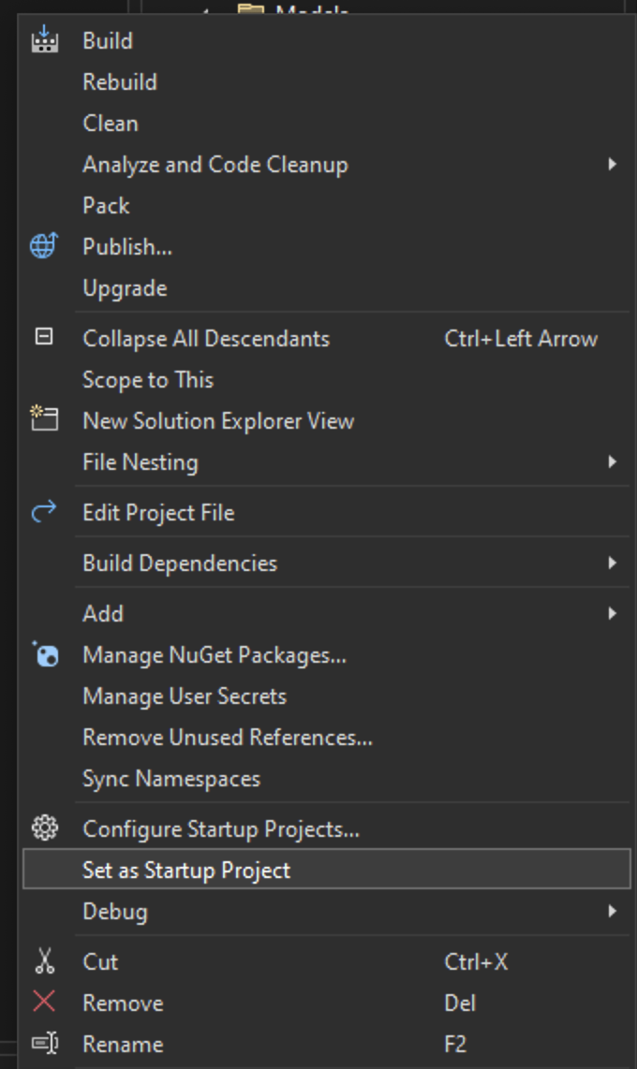

Figure : Setting the startup project to the GUI app

1. Now that our project is set up, we can begin to add functionality to our VehicleModel store. Begin by opening the code for FrmVehicleStore and adding a citation as shown in .

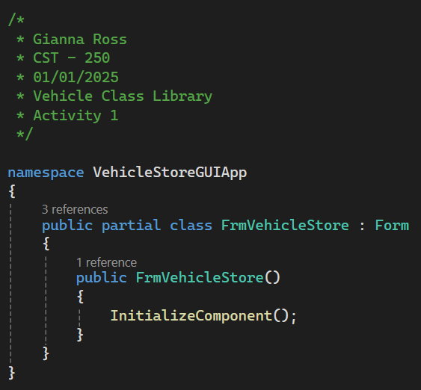

Figure : FrmVehicleStore with a citation

1. We will create 4 Click event handlers, one for each vehicle type radio button. Add a click event handler to rdoCar by selecting the radio button, navigating to the event tab in the properties window and selecting the Click event as shown in .

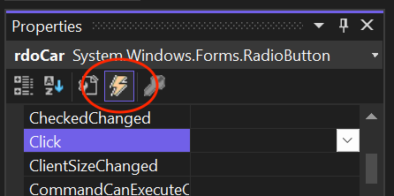

Figure : Finding the click event handler for rdoCar

1. The naming convention we will use for event handlers is "[Control Name][Event Name]EH" in PascalCase. This allows us to quickly understand that our method is an event handler, what the control is used for, and what the event itself is. Our event handler for the car radio button will be RdoCarClickEH as shown in . By creating the event handler manually rather than double-clicking the event, we can ensure the use of proper naming conventions for method.

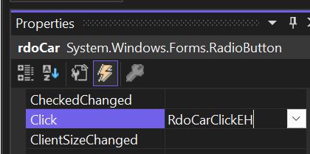

Figure : Naming an event handler

1. Once you enter the name for the event handler, the method should be automatically created in your backend code as shown in . Make sure to add a summary comment to the method.

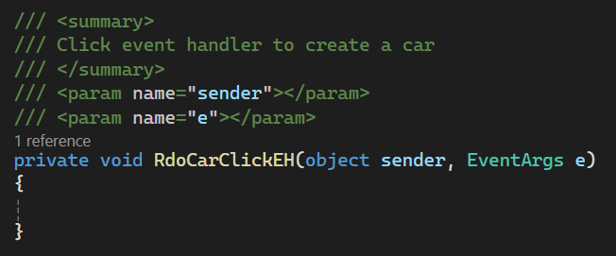

Figure : Starting the RdoCarClickEH method

1. Before we can add the code to create a car, we need to create a class level variable to store the current vehicle being created. At the top of FrmVehicleStore, create a string variable named currentVehicleType as shown in . We can use the constructor provided to initialize the variable to an empty string. Make sure to add a summary comment to the constructor.

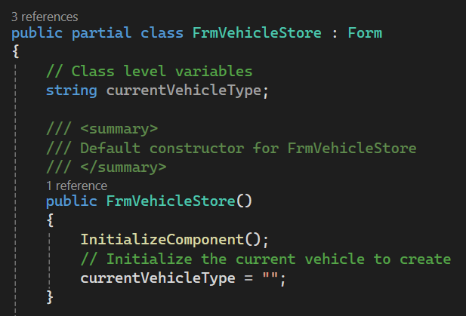

Figure : Creating a class level variable to store the current vehicle type

1. Back in the car click event handler, we can start by updating the variable we just created to hold a "Car" string as shown in . This will let our program know what type of vehicle to create when the user selects the Create button.

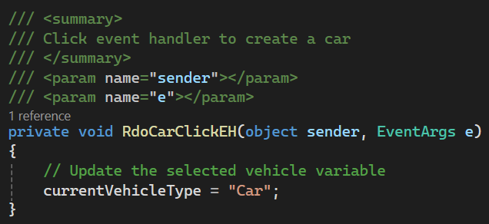

Figure : Updating the current vehicle type

1. Next, we can update the labels for the specialty Boolean and decimal. We can update the Text for the labels to reflect the specific car properties as shown in .

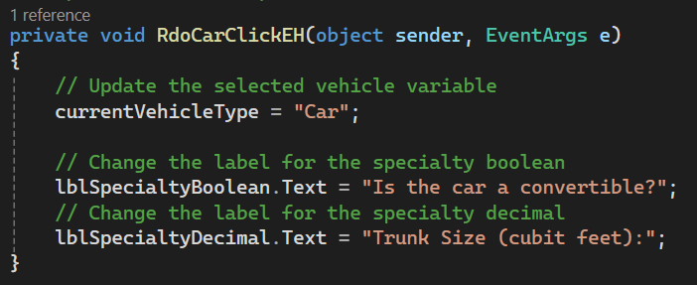

Figure : Updating the labels for the specific car properties

1. Lastly, we will need to ensure that the labels, radio buttons, and text box are shown to the user that. We can update that using the Visible property of each control as shown in .

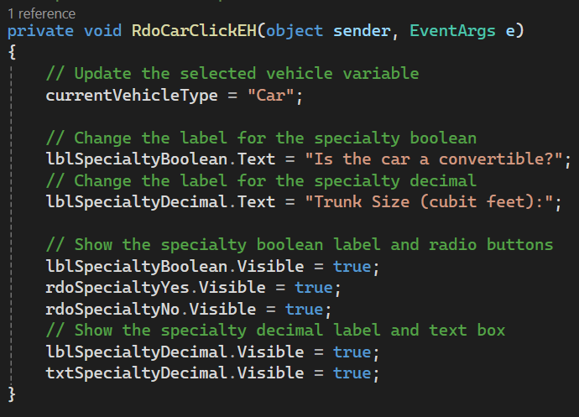

Figure : Showing the specialty controls for the car



* Commit all changes in the project to source control.
* Commit Message: Commit the UI design and functionality for the car button.

1. Run the program and select the Car radio button. You should see the labels update to match the car-specific properties. However, you can also see that our error labels are currently visible. We can fix that by individually hiding each label in the constructor of our form, as shown in .

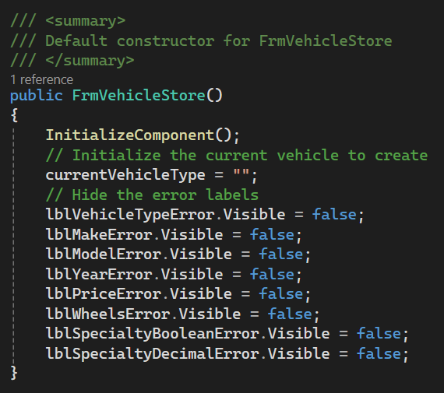

Figure : Hiding the error labels in the constructor

1. Now that our error labels are hidden, we can continue setting up our radio buttons for the vehicle types. Add a click event handler named RdoMotorcycleClickEH to rdoMotorcycle as shown in . Add a summary comment to the new method as shown in .

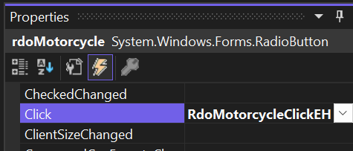

Figure : Creating RdoMotorcycleClickEH

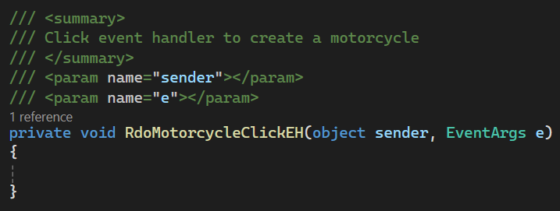

Figure : RdoMotorcycleClickEH with a summary comment

1. The code for this event handler will mirror the code for the car event handler. Update the current vehicle type, the labels for the specialty Boolean and decimal, and ensure that all the controls are shown, as shown in .

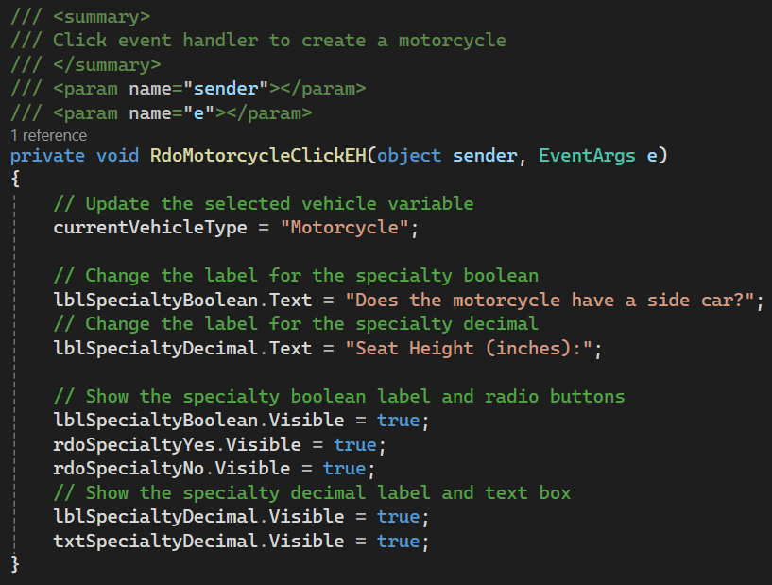

Figure : Completed code for the motorcycle radio button

1. Add a third click event handler for the pickup with a summary comment as shown in .

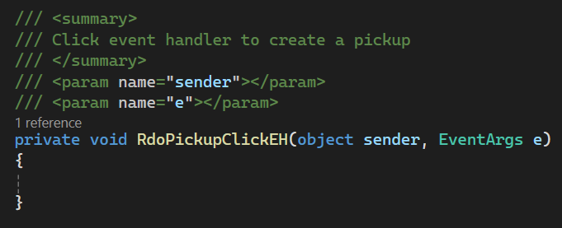

Figure : RdoPickupClickEH with a summary comment

1. Add code mirroring the first two event handlers to update the current vehicle type, the labels for the specialty Boolean and decimal, and ensure that all the controls are shown as shown in .

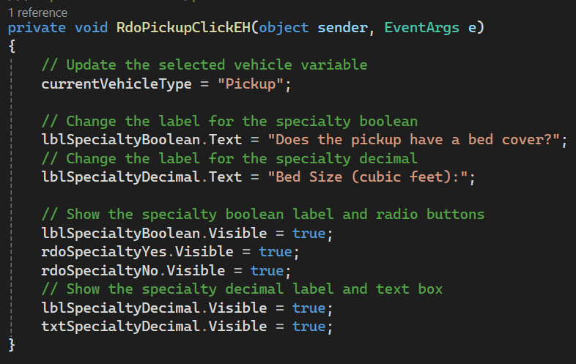

Figure : Update the specialty group box for a pickup.

1. Add a click event handler to rdoVehicle as shown in . Remember to add a summary comment.

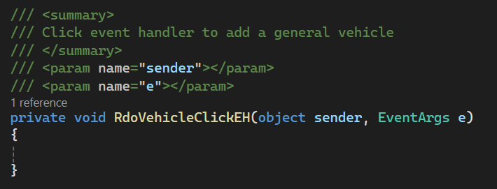

Figure : RdoVehicleClickEH with a summary comment

1. Since the standard vehicle has no specialty properties, we will not need to update the labels for creating a vehicle. Instead, we should hide the specialty Boolean and decimal controls as shown in . However, we will still need to update the current vehicle variable.

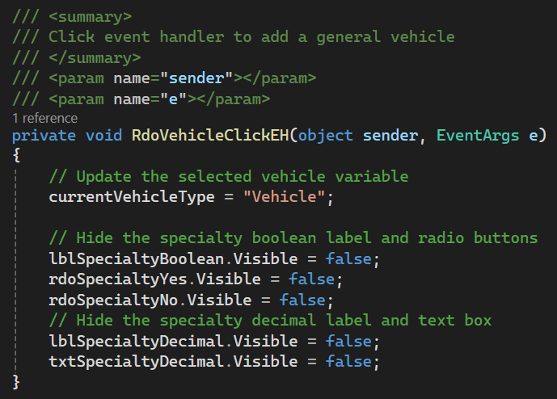

Figure : Finished RdoVehicleClickEH

1. Now that the user can select the necessary specialty properties for each or our vehicle types, we need to add functionality to our create button. Add a click event handler with a summary comment to the Create button named BtnCreateClickEH as shown in .

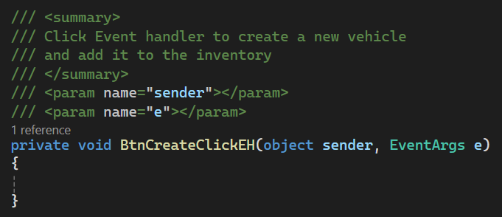

Figure : BtnCreateClickEH method with summary comment

1. To ensure we have correct information from the user, we will create flags and method ensure each user input is validated and to avoid repeated code. Begin by creating a class-level Boolean variable, also known as a flag, for each user input as shown in . These flags should all be set to false.

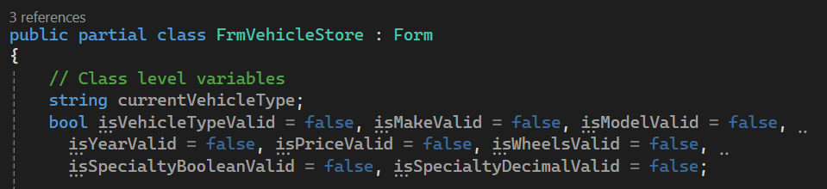

Figure : Class-level flags for each user input

1. Start the validation methods by creating a method to validate the user entering a vehicle type with a summary comment as shown in . Since nothing outside of the class will reference this method, it can be declared as private. This method will check all four radio buttons to ensure that one is selected. If none are, show the error label and set the flag to false. Else, hide the label and set the flag to true.

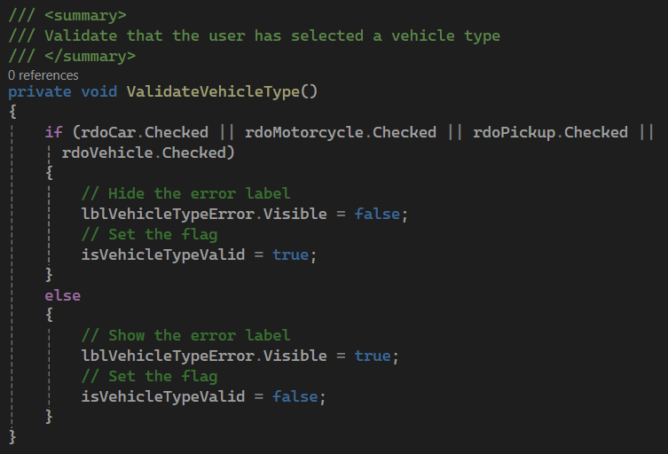

Figure : Method to validate the vehicle type selection

1. Next, create a private method to validate the make textbox that returns a string. This method will make sure that the input is not null or empty and return the text for the textbox, as shown in .

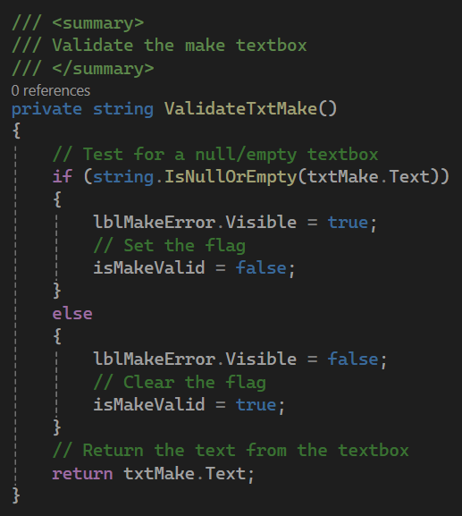

Figure : Method to validate the make text box

1. Next, add a private method named ValidateTxtModel that returns a string as shown in . This method will have similar code to the method to validate the make text box. Remember to add a summary comment to the method.

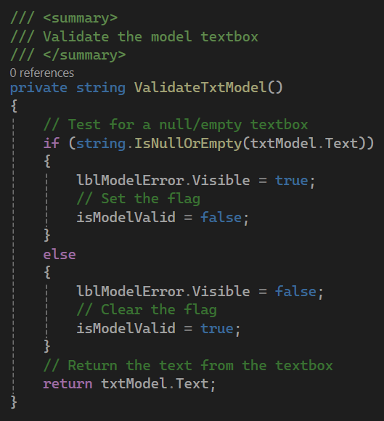

Figure : Method to validate the model text box

1. Create a fourth private method with a summary comment named ValidateTxtYear that returns an integer. As well as making sure that the textbox contains data, this method will make sure that the user has inputted a proper number as shown in . The TryParse method will return a Boolean based on the success of the parse. The output of parsing the first parameter will go to the out parameter variable.

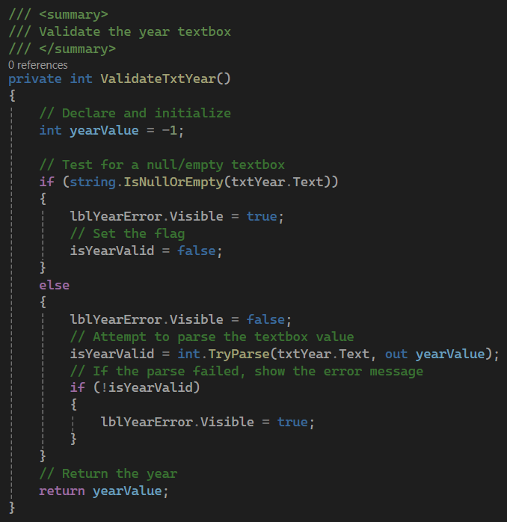

Figure : Validate the year text box.

1. To validate the price, create another private method named ValidateTxtPrice that will return a decimal. The logic for this method will mirror the logic to validate the year as shown in . Don't forget to add a summary comment to the method.

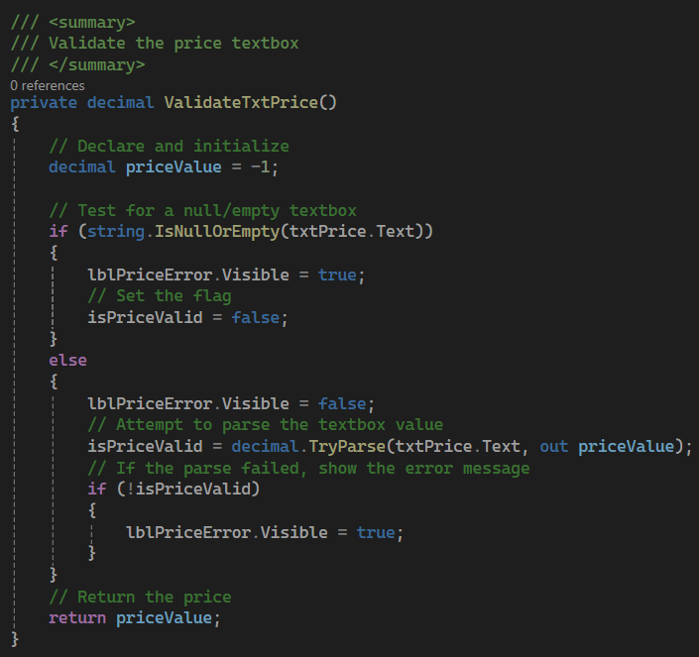

Figure : Method to validate the price text box

1. To validate the number of wheels entered by the user, create a private method with a summary comment named ValidateTxtWheels that returns an integer. The logic for this method will mirror the logic to validate the vehicle year as shown in .

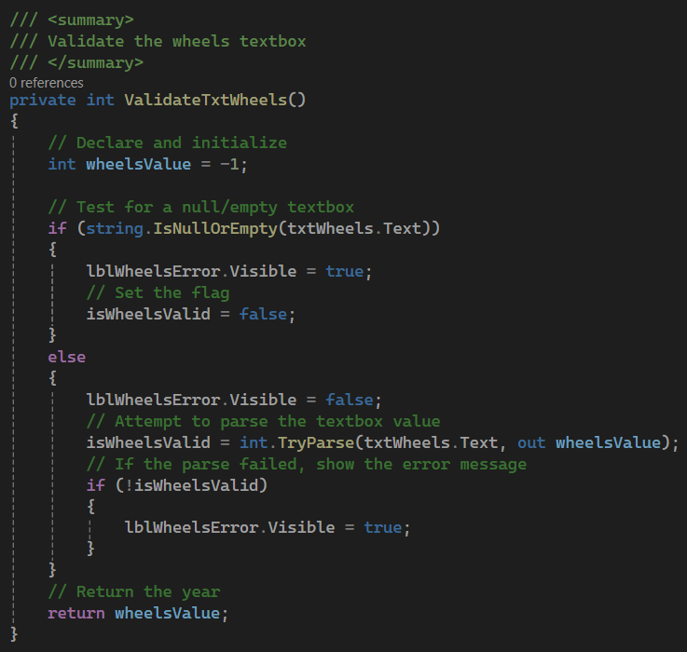

Figure : Method to validate the number of wheels entered by the user

1. To validate the specialty Boolean, we will make sure that one of the radio buttons is checked. Start by creating a private method named ValidateSpecialtyBoolean with a summary comment that returns a Boolean. If the currently selected vehicle is "Vehicle," we can automatically set the flag to true and hide the error label. Otherwise, ensure that one of the Yes or No radio buttons is selected. Else, show the error label and set the flag to false, as shown in . We can return the status of the Yes radio button checked. If it is checked, it will return true. If it is not checked, we assume that the No radio button is checked, so a false return is correct.

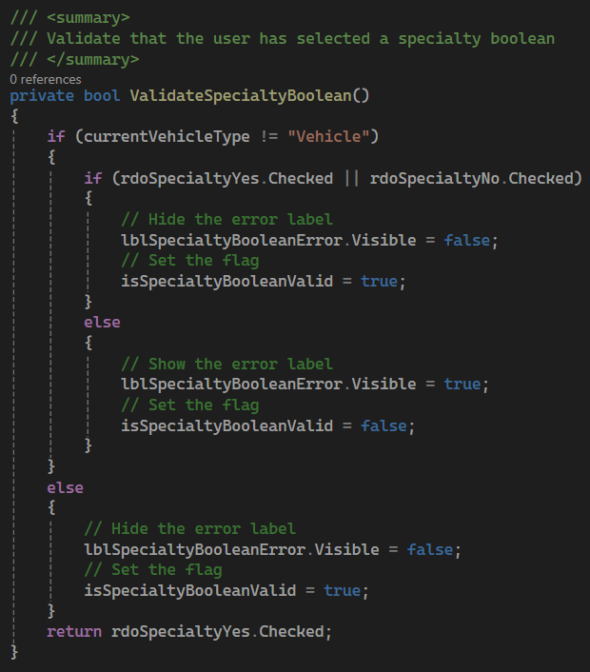

Figure : Method to validate the specialty Boolean

1. Lastly, create a method named ValidateSpecialtyDecimal with a summary comment that returns a decimal. First, check to make sure the current vehicle isn't "Vehicle." If it isn't, make sure that the textbox contains valid data as shown in . Return the parsed data from the method. If the current vehicle is "Vehicle," hide the error label and set the flag to true.

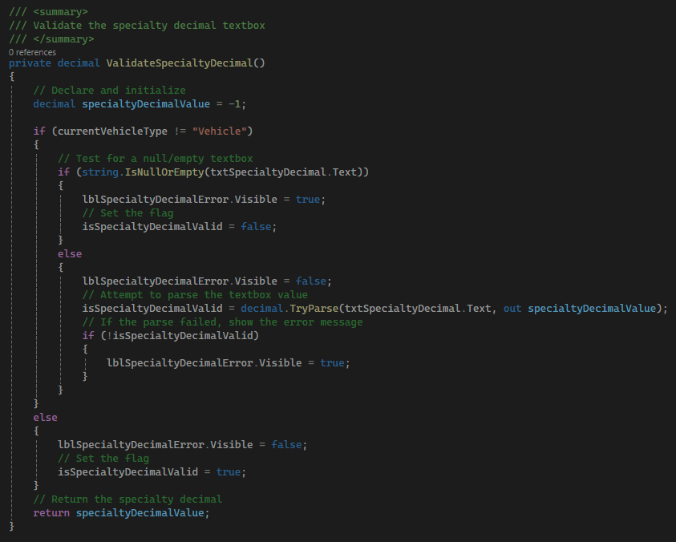

Figure : Method to validate the specialty decimal

1. Back in the create button click event handler, we will need to read text from the text boxes to get the attributes of our new vehicle. Declare variables for the make, model, year, price, wheels, specialty Boolean, and specialty decimal of the vehicle as well as a variable to hold a VehicleModel. Then, use the created validation method to get the data for each variable as shown in .

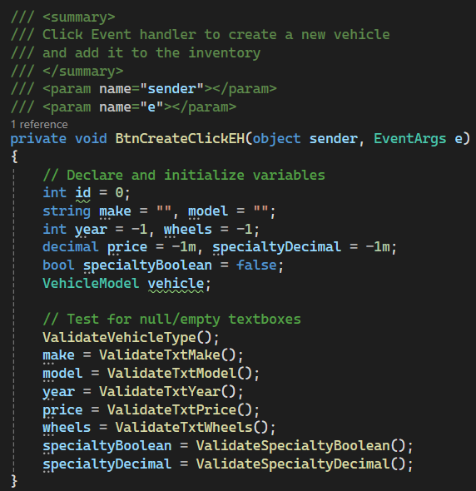

Figure : Create button click event handler to get user entered data.

1. Next, check the state of all eight flags to ensure that the user has entered all data correctly. If so, use a switch statement based on the current vehicle type to create the correct type of vehicle as shown in .

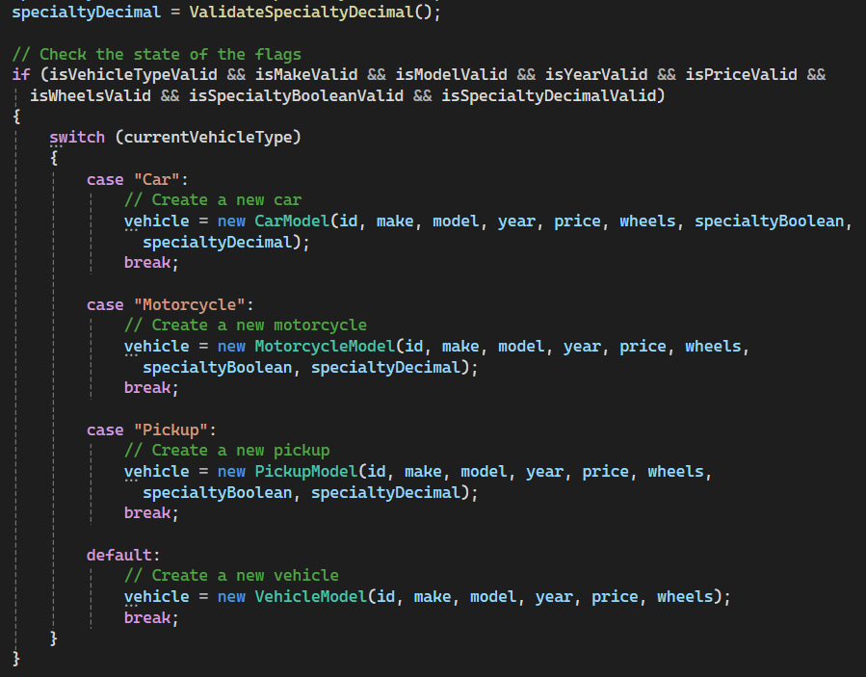

Figure : Check the flags and create the correct vehicle.

1. The last thing we need to do before we can add the new VehicleModel is declare an instance of the vehicle store logic class. Since we only want one store object, this will be done at the class level. This variable should be private as we do not want other classes being able to access it. The naming convention for private variables is _camelCase, so the variable name will be _storeLogic. Declare this variable and initialize it in the constructor as shown in .

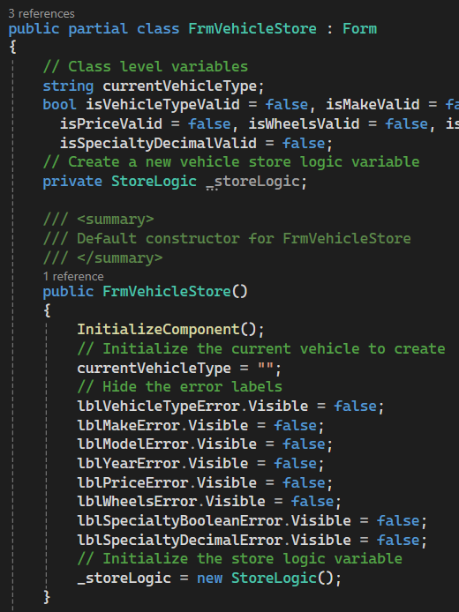

Figure : Creating a StoreLogic variable

1. To complete the logic to add a new vehicle, use the _storeLogic variable to add the new VehicleModel, show the user that the new VehicleModel has been created using string interpolation and the ToString we created earlier, and clear the text boxes to make space for the next vehicle to be added as shown in .

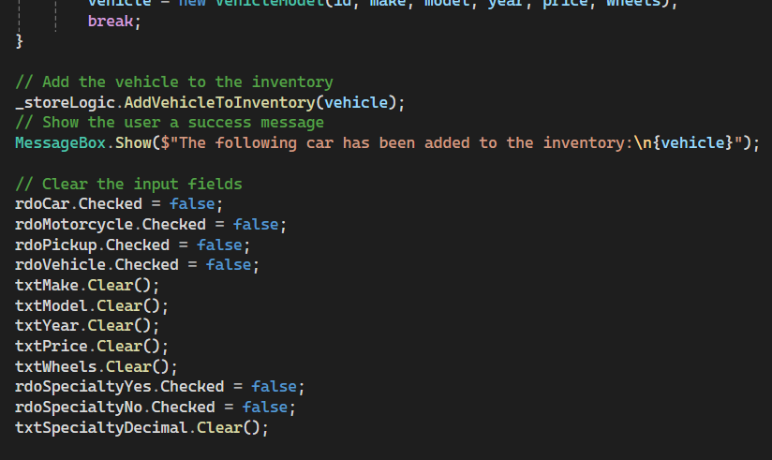

Figure : Add the vehicle and clear the user input fields.

1. To populate the inventory and shopping cart list controls, we will need to use a binding source as an intermediary between the list and the data source, which will be our lists from the StoreDAO. This will allow changes in the lists to be reflected in the list boxes in our GUI with one method call. First, we need to create two private binding source objects for our inventory and shopping cart lists named _inventoryBindingSource and _shoppingCartBindingSource, as shown in . Then, set them to be our data sources for our list controls. This will be done in the form constructor by setting the data sources for the binding source objects, then setting the data source for each list control to the correct binding source, as shown in .

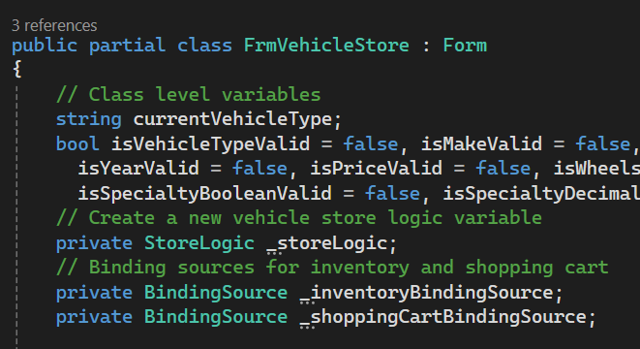

Figure : Declaring the binding source objects

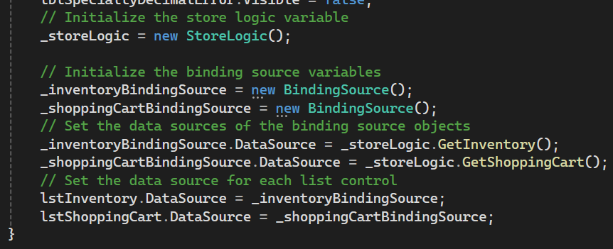

Figure : Linking the list controls to the inventory and shopping cart lists

1. Then, we can use the ResetBindings method in the BtnCreateClickEH method to refresh the inventory list after we add a new VehicleModel as shown in . By adding the false parameter, it signifies that the object type of the list has not changed. Run the program to make sure that you can create all types of vehicles with no issues.

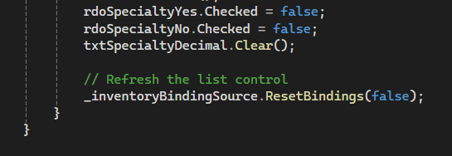

Figure : Resetting the bindings for the inventory binding source



* Commit all changes in the project to source control.
* Commit Message: Add functionality for the create vehicle button.

1. Based on the way our program is currently set up, the user must select the Create button to see if their data is valid. To make the user experience better, we can add leave and click event handlers to the text boxes and radio buttons so that we can display errors sooner to the user. Add a Leave event handler to each of the 6 text boxes for user input. Add a summary comment and a call to the corresponding validation method to each, mirroring .

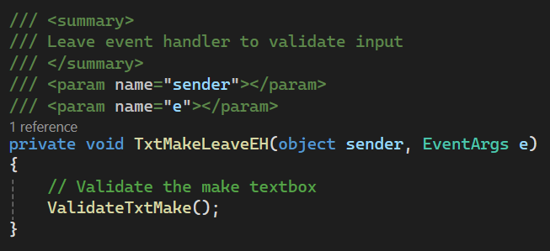

Figure : Example for a leave event handler

1. Instead of a leave event handler for the vehicle type and specialty Boolean, we will use a click event handler. We will start with the vehicle type because we already have those event handlers set up. Add a call to ValidateVehicleType to each of the click event handlers for the vehicle types, mirroring .

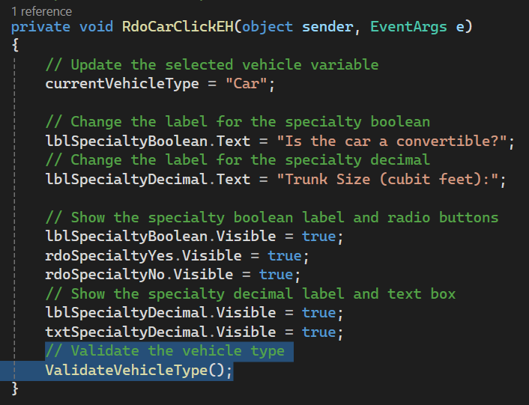

Figure : Validating the vehicle type

1. To validate the specialty Boolean, we will create a new Click event handler named RdoSpecialtyBooleanClickEH to attach to both rdoSpecialtyYes and rdoSpecialtyNo. This method will call the ValidateSpecialtyBoolean method as shown in .

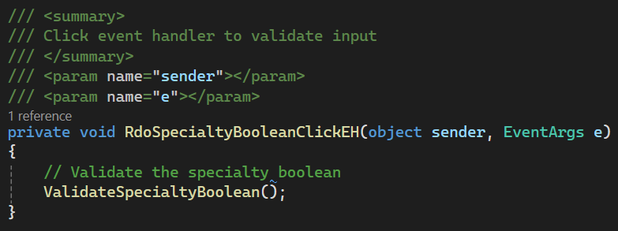

Figure : Validating the specialty Boolean



* Commit all changes in the project to source control.
* Commit Message: Add leave and click event handlers to improve user experience.

1. Now that we can add a new VehicleModel to the inventory, we need to be able to add a VehicleModel from the inventory to the shopping cart. First, add a new click event handler to the "Add to Cart" button named BtnAddToCartClickEH as shown in . Then, add a summary comment to the created method as shown in .

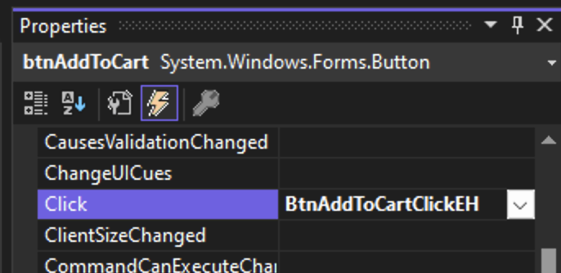

Figure : Adding a click event handler to btnAddToCart

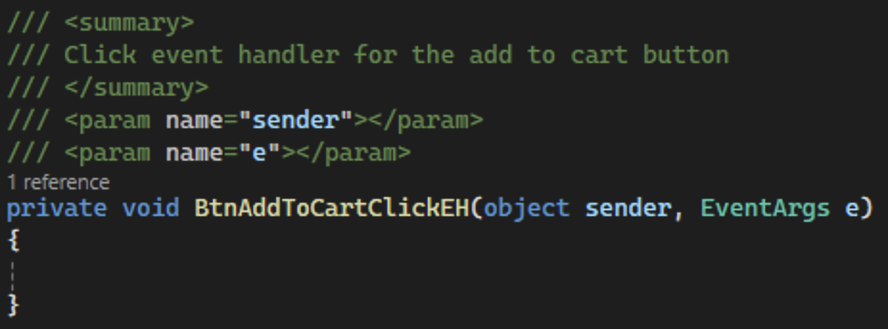

Figure : BtnAddToCartClickEH with summary comment

1. Next, we need to populate the method with logic to add the VehicleModel to the shopping cart. To find the VehicleModel that is selected, we can use the SelectedItem property of the list control. We don't need to know what specific type of vehicle we are dealing with here because we are only sending the ID to the business logic layer. We can then send the VehicleModel's ID to the business logic layer of the VehicleClassLibrary and reset the bindings of the shopping cart binding source to update the list control as shown in .

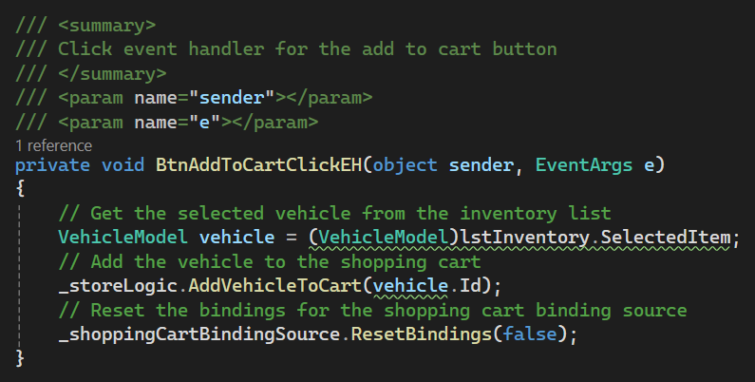

Figure : Adding a VehicleModel from the inventory to the shopping cart

1. To finish the GUI version of this application, we need to add functionality for the checkout button. First, add a click event handler named BtnCheckoutClickEH and add a summary comment to the created method as shown in .

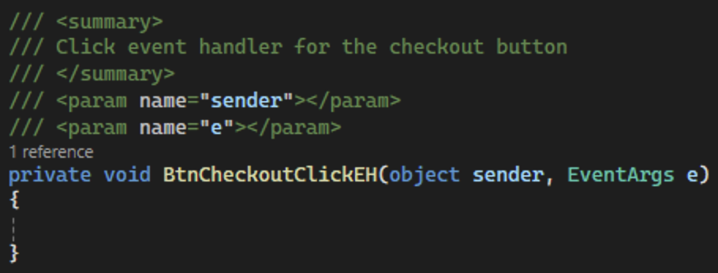

Figure : Click event handler for btnCheckout

1. When the user clicks the checkout button, we should call the checkout method in the business logic layer, store the resulting total, and update lblTotal with the formatted total as shown in . Like using C in string.Format, the C parameter will format the total as currency.

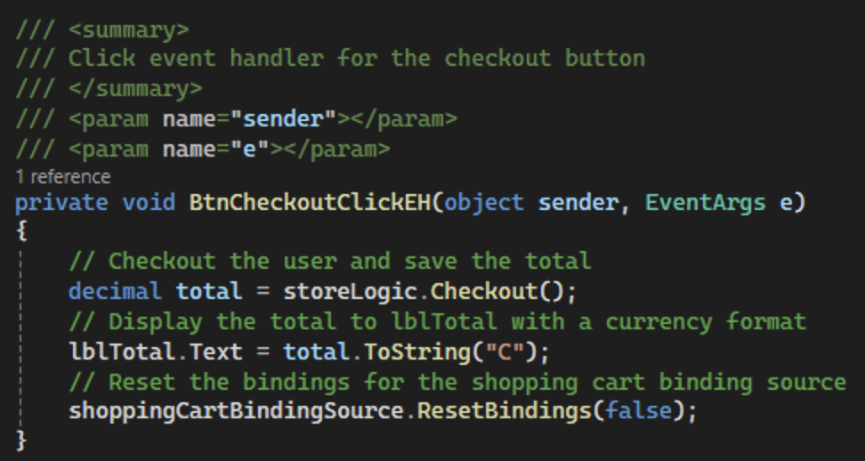

Figure : Logic for the checkout button click event handler



* Commit all changes in the project to source control.
* Commit Message: Add functionality for the add to cart and checkout buttons.

1. Run the application, add some VehicleModels to the inventory, add a few items to the cart, and click checkout.



* Take a screenshot of the application running at this point.
* Take a screenshot of the citation for FrmVehicleStore. Make sure to include the class declaration in the image.
* Take a screenshot of the FrmVehicleStore, RdoCarClickEH, RdoMotorcycleClickEH, RdoPickupClickEH, RdoVehicleClickEH, BtnCreateClickEH, ValidateVehicleType, ValidateTxtMake, ValidateTxtModel, ValidateTxtYear, ValidateTxtPrice, ValidateTxtWheels, ValidateSpecialtyBoolean, ValidateSpecialtyDecimal, TxtMakeLeaveEH, TxtModelLeaveEH, TxtYearLeaveEH, TxtPriceLeaveEH, TxtWheelsLeaveEH, TxtSpecialtyDecimalLeaveEH, RdoSpecialtyBooleanClickEH, BtnAddToCartClickEH, and BtnCheckoutClickEH methods.
* Take a screenshot of the UML for the FrmVehicleStore class.
* Paste the images into a Microsoft Word document.
* Put a caption below each image explaining what is being demonstrated.

## **GUI App Challenges**

Choose at least four of the following features to enhance the program:

1. **Two properties –** Implement functionality for the two properties you added for the console app including text boxes, flags, and data handling.
2. **Search for Inventory –** Implement a search method in the inventory list to allow users to quickly find VehicleModels by make, model, or year. This could use a text box for input and filter the list control based on user input.
3. **Remove Vehicle from Shopping Cart** – Add functionality to remove a selected VehicleModel from the shopping cart.
4. **Sort Inventory** – Add buttons or a dropdown menu to sort the VehicleModel inventory by price, year, or make/model alphabetically. Research the "Comparison" class to accomplish this task.
5. **Save and Load Inventory from a text File** – Implement functionality to save the current state of the VehicleModel inventory list to a file and load it back into the program.
6. **Duplicate Vehicle Entry Prevention** – Before adding a VehicleModel to the inventory, check if an identical vehicle (identical in all properties) already exists to prevent duplicate entries. Override the equals() method in the vehicle classes to enable duplicate checks in the inventory list.



* Commit the challenges to source control with a commit message/



* Take a screenshot of the application running after the new features have been added.
* Take a screenshot of each method added or updated to implement the features.
* Take a screenshot of the updated UMLs for any classes with added methods.
* Paste the images into a Microsoft Word document.
* Put a caption below each image explaining what is being demonstrated.

# What You Learned in This Activity

**Part 1 – Test Driven Development (TDD)**

1. Learn how to write unit tests before implementing code, using the TDD cycle: Red → Green → Refactor to guide software design and ensure testable, high-quality solutions.
2. Develop proficiency with xUnit to create automated tests that validate functionality, prevent regressions, and promote clean, modular architecture in C# applications.

**Part 2 – VehicleModel Class Library**

1. **Class Creation and Utilization**: You've learned how to construct a versatile class library, creating fundamental classes like the VehicleModel, CarModel, MotorcycleModel, PickupModel, StoreLogic and StoreDAO classes that form the backbone of both the console and GUI applications. These classes are structured to encapsulate all the business logic and data handling, demonstrating effective object-oriented programming principles.
2. .**NET Framework and Cross-Platform Capabilities**: We explored the features of the .NET 8.0 framework and its cross-platform functionality, enhancing your understanding of modern application frameworks and their execution environments.

**Part 3 – Console Application**

1. **Console-Based User Interaction**: You've gained hands-on experience in building a console application that utilizes the class library for business logic. This part emphasized reading user input, processing it, and responding with appropriate outputs, reinforcing your skills in creating interactive console applications.
2. **Real-World Application Structures**: Through setting up and linking multiple projects within a single solution, you've learned how real-world applications are structured and how to manage them using Visual Studio, particularly focusing on integrating different layers of an application seamlessly.

**Part 4 – GUI Vehicle Store**

1. **GUI Development with WinForms**: Transitioning from a console to a graphical user interface using Windows Forms, you've seen firsthand how to construct a more user-friendly interface using the same underlying business logic. This part not only enhanced your skills in GUI design but also in binding data to UI components effectively.
2. **Event Handling and UI Management**: By connecting UI elements like buttons and list boxes to the business logic, you learned to manage application state reactively, responding to user interactions such as button clicks to update the application data dynamically.

# Check for Understanding

These quiz questions will help you review important concepts from the lesson. These are not graded. You do not have to submit your score.

1. What is the primary function of the .NET 8.0 used in the Vehicle Store application?
   1. To provide a programming environment only for Windows applications.
   2. To serve as a database management tool.
   3. To restrict the development to mobile applications.
   4. To allow developers to create applications across various platforms.
2. Which statement best describes the purpose of a class library in the Vehicle Store application context?
   1. It is used to manage the user interface of both the console and GUI applications.
   2. It contains business logic and data structures like the VehicleModel, CarModel, MotorcycleModel, PickupModel, StoreLogic and StoreDAO classes, used by both the console and GUI applications.
   3. It handles all the data storage directly, writing data to the disk.
   4. It serves as the compiler for the Visual Studio environment.
3. What role does the BindingSource play in the GUI version of the VehicleModel Store application?
   1. It acts as an intermediary between the data lists and the GUI components.
   2. It compiles the code into executable files.
   3. It is used to directly store data into databases.
   4. It manipulates business logic during runtime.
4. What is the primary reason for using the same VehicleClassLibrary in both the console and GUI applications?
   1. To ensure that both applications can only run on Windows.
   2. To separate the user interface from business logic and data handling, allowing code reusability.
   3. To increase the complexity of the application for better security.
   4. To use more system resources and make the application slower.
5. What does moving from a console app to a GUI demonstrate in software development?
   1. The unnecessary complexity of simple applications.
   2. The importance of having multiple user interfaces for the same application logic.
   3. The separation of concerns, showing how user interface changes do not affect underlying business logic.
   4. That GUI applications are inherently better than console applications.

**Answer Key:**

1. What is the primary function of the .NET 8.0 used in the Vehicle Store application?

d. To allow developers to create applications across various platforms.

2. Which statement best describes the purpose of a Class Library in the Vehicle Store application context?

b. It contains business logic and data structures like the VehicleModel, CarModel, MotorcycleModel, PickupModel, StoreLogic and StoreDAO classes, used by both the console and GUI applications.

3. What role does the BindingSource play in the GUI version of the Vehicle Store application?

a. It acts as an intermediary between the data layers and the GUI components.

4. What is the primary reason for using the same VehicleClassLibrary in both the console and GUI applications?

b. To separate the user interface from business logic and data handling, allowing code reusability.

5. What does moving from a console app to a GUI demonstrate in software development?

c. The separation of concerns, showing how user interface changes do not affect underlying business logic.

# Deliverables

You must submit **two separate files**:

* One **PDF** containing Parts 1–3.
* One **zip file** containing the complete codebase for Part 4.

**Part 1: Activity Submission**

1. Cover Page
   * Use APA formatting for the cover page.
2. GitHub Repository Link
   * At the top of the second page, provide a link to your private GitHub repository.
   * Be sure to add your instructor and grading assistant (if applicable) as collaborators so they can access your repository.
3. Updated Flowchart
   * Include the latest flowchart reflecting your current application design.
4. Updated UML Diagram(s)
   * Provide UML diagrams that reflect the current implementation.
5. Base Application Screenshots
   * Include screenshots as required in the activity instructions.
   * Each screenshot must have a clear caption directly below the image explaining what is being demonstrated.
   * All code must be properly commented.
6. Section Headers
   * Use clear headers as outlined in these deliverables to identify each part of the assignment within the PDF.
7. Citations
   * Include a citation at the top of each page containing code, flowcharts, or UML diagrams.
8. File Naming
   * Name the PDF according to the activity title and include your full name.
9. Coding Standards Compliance
   * Make sure that the GCU College of Engineering and Technology Coding Guidelines and Best Practices, found in Class Resources, have been followed to ensure consistency, readability, and professionalism in student code.

**Part 2: Activity Challenges**

1. Challenge Screenshots
   1. Include screenshots that demonstrate completion of the Challenge requirements as described in the activity guide.
2. Minimum Features
   1. Console App Challenges
      1. Implement and document all challenges.
   2. GUI App Challenges
      1. Implement and document at least four features from the Challenge section.

**Part 3: Planning for Topic 2 Activity 2**

1. Flowchart for Topic 2 Activity 2
   1. Use the requirements as outlined in Topic 2 Activity 2 to create a high-level flowchart. Showcase the logic and data flow that can be used as a template for the software design.
2. UML Diagram(s) for Topic 2 Activity 2
   1. Provide UML diagram(s) based on the same requirements.

Part 4: Code Submission (Separate Zip File)

1. Zip Your Project Folder
   1. Compress the full folder containing all source code and necessary files into a .zip file.
2. Executable Submission
   1. Ensure the application runs correctly. The zip file will be unzipped and tested during grading, so include all dependencies.
3. File Naming
   1. Name the zip file according to the activity and include your full name.

**Submission Reminder**

**Do not submit a single zip file that contains both the PDF and the code.** Each file must be uploaded separately.